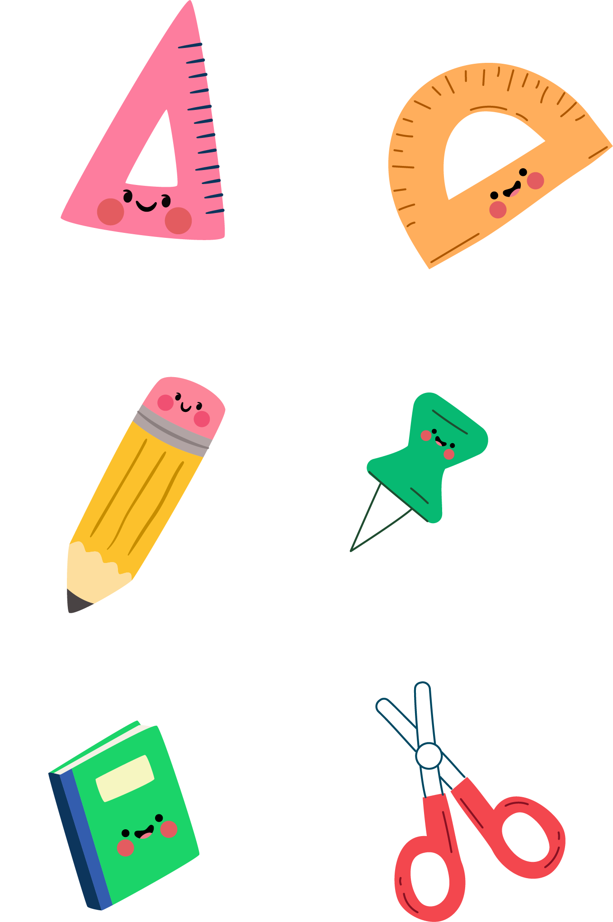 **Unit 6 At the snack bar(Period 3)练习单**

**Task 1.Read and fill 选词填空，使句子意思通顺**

relax（放松） six sax（萨克斯）

1.It’s .I want to and play my .

axes（斧子） taxi six

2 .-How many can you see in the ?

-Just .

Rex mixer（料理机） fix(修理） box

3. can the in the .

**提示：**遇到困难的题目，先在小组内说一说，再一起合作完成。

**Task 2.Make a new rhyme 改编小诗。**

《What would you like?》

What would you like ?

What would you like?

I’d like_____________.

I’d like_____________.

They’re all very nice.

**提示**：除了菜单上的食物，你也可以有别的选择。改编的最押韵的，可以得到额外积分哦！

**Task 3.Ticking time**今天你学得怎么样啊？来为自己打打分吧!

|  |  |  |  |
| --- | --- | --- | --- |
| Ticking time | ★★★ | ★★ | ★ |
| 1. I can name some food and drinks.我会说食物和饮料的名称。 |  |  |  |
| 2. I can use “order food. 我会点餐。 |  |  |  |
| 3. I know the sound of the letter “x”.我知道字母x的发音。 |  |  |  |