六年级英语阶段检测卷
姓名____________学号____________得分____________
听力部分(25)

一．听录音，选出你所听到的内容(10)
( )1. A. put B. but C. pot
( )2. A. get off B. take off C. turn off
( )3. A. they B. their C. them
( )4. A. camp B. comb C. come
( )5. A. ours B. house C. out
( )6. A. save water B. save energy C. save trees
( )7. A. coal B. oil C. Earth
( )8. A. paper B. plastic C. wood
( )9. A. bag B. bottle C. drive
( )10.A.on the 22nd of April B. on the 5th of June C. on the 1st of October
二．听录音，根据问句选答句。(5)
( )1. A.To make a box. B. To make a toy. C. To make a box and a toy.
( )2. A.Yes,it is. B. Yes, they do. C. No, it isn’t.
( )3. A.Yes,there is. B. Yes, that is. C. No, there isn’t.
( )4. A.Coal. B. Oil. C. Coal and oil.
( )5. A.Sweep the floor. B. Take the bus to school. C. Plant more trees.
三．听录音，根据所听内容填入所缺的单词，完成短文。(10)
How to protect the Earth? First, we shouldn’t 1. _________ here and there. We should 2. _________ the rubbish up and put 3. _________ in the bin. Second, we shouldn't use 4. _________ many plastic 5. ____________. Plastic is 6.___________ for our Earth. Third, we should 7. _________ more trees. Trees can not only make our Earth more 8. __________ but also 9. _________ keep the 10. _________ clean.
笔试部分（75）
一、选出与所给单词画线部分发音相同的一项。(5)
( )1. useful A. bus B. put C. student
( )2. plastic A. face B. paper C. bag
( )3. waste A. cake B. cap C. glass
( )4. wood A. took B. school C. food
( )5. smoke A. move B. sorry C. metro
二、单项选择(10)
( )1. What would you like to ____? I’d like _____ orange juice.
- drink, drinking B. drink, to drink C. drink, drink
( )2. ____, please. My sister is sleeping.
- No smoking B. No parking C. Be quiet
( )3.Your pen is on the floor. Please_____.
- pick up it B. pick them up C. pick it up
( )4.We use water _____ clothes every day.
- wash B. to wash C. washing
( )5. Coal is _____ useful energy.
- a B. an C. /
( )6. Mr Brown ____ from the US.
- come B. comes C. is comes
( )7. There are so many _____ in the water.
A. rubbish B. fish C. plastic
( )8. Smoke is bad ______ the air.
- for B. at C. on
( )9. There ____ a lot of ____ on the desk.
A. is, papers B. is, paper C. are, paper
( )10. You should not drive ______.
- so many B. too many C. so much
三、用括号中的词的适当形式填空(8)
1. We should ________(eat) fruit and vegetables every day.
2. Mr green__________(drink) too much yesterday.
3. _______________(not waste) water, please.
4. He starts____________(draw).
5. There are three plastic __________(bottle) on the table.
6. The books are__________ (use). They are good for your study.
7. We use wood ____________(make) things.
8. There __________(be) not much oil on Earth.
四、根据句意和首字母填空(8)
1. You should not waste paper. You should s________ paper.
2. Oh,what a day! It’s r_________ now. It often r________ in summer.
3. You are so fat. You shouldn’t eat too m________.
4. W______ comes from trees.
5. Most of our energy c_______ from c________ and oil.
6. Please throw these three plastic b_________into the bin..
五、从I栏中选出与I栏相对应的答句。(5)
I II
( )1. How can we keep the air clean? A. It's on 22nd April.
( )2. What shouldn't they do? B. We can plant more trees.
( )3. Is there too much oil on Earth? C. Yes, he does.
( )4. Does your brother live in the city? D. No, there isn't.
( )5. When is Earth Day? E.They shouldn't waste water.
六、句型转换(8) X |k | B | 1 . c|O |m
1. Sam goes to school on foot. (同义句)
Sam _________ _________ school.
- Miss Li sat at the back of the bus.( 改成否定句)
Miss Li __________ _________ at the back of the bus.
- They had an English lesson now.(用now 改写句子)
_________ _________ an English lesson now.
- It’s rainy today.(对划线部分提问)
_________ the _________ like today?
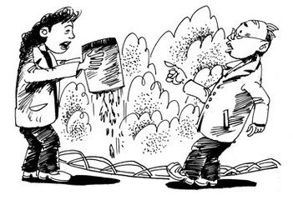
七、根据图片情境，补全对话，每空一词。（8分）
1. A: What is she _______ now?
B: She is putting_________ in the river.
A: Can we ________ there?
B: No, we can’t.
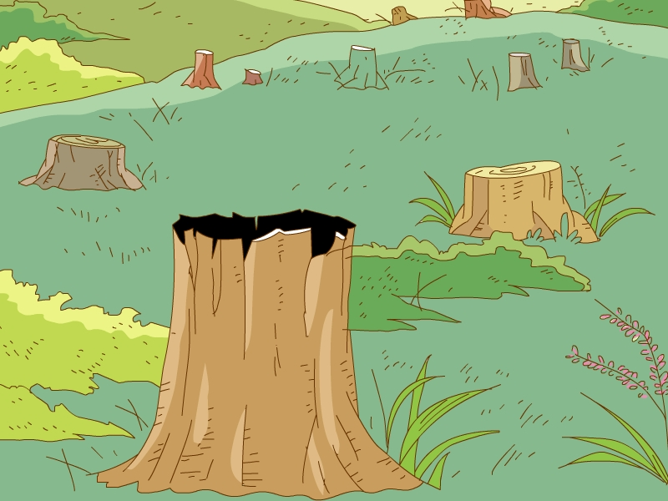
2. A: Can we________ down too ______ trees?
B: No, we can’t
A: Why?
B: Trees can keep the ________ _________.
A: What can we use the wood to do?
B: We can use the wood to________ tables, chairs and many other things.
八、完形填空(8)
When you are in Britain you often see people go out 1. an umbrella or a raincoat on a sunny day. 2. ? Because the weather in Britain often changes (变化) quickly. The same weather doesn’t stay long . People can have four seasons in one day. In the morning the weather is warm like in 3. . After an hour, black 4. come and then it 5. . The weather gets 6. . In the afternoon it will be 7. .The sun will begin to shine, and it will be summer at this time of a day. The weather is always changing. How 10. it is!
( ) 1. A. for B. with C. use
( ) 2. A. Why B. What C. How
( ) 3. A. winter B. spring C. summer
( ) 4. A. cloud B. clouds C. sky
( ) 5. A. rains B. rained C. rainy
( ) 6. A. cold B. hot C. warm
( ) 7. A. cloudy B. sunny C. windy
( ) 8. A. exciting B. useful C. interesting
九、阅读理解(10)
(A)阅读判断正确的写（T）错误的写（F）
Earth Day is on 22nd April. It is a special day to learn about our planet and how to protect it.
On Earth Day, some people listen to speeches about the environment. Others help clean up their offices or save water and electricity (电) at home. Some people may even(甚至) decide（决定）to take a day off from driving their cars.
The idea for Earth Day came from a US senator(参议员). He was worried about the pollution and the health of plants and animals. And the idea quickly caught on(流行起来). In 1970, the first Earth Day was celebrated. Millions of people in cities all over the US took part in it. Since then, Earth Day has been used to educate people about their roles in taking care of our planet（行星）. Now, Earth Day has become a global（全球的） celebration.
( )1. 22nd June is Earth Day.
( )2. The idea for Earth Day came from a UK senator.
( )3. Some people may take a day off from driving their cars.
( )4. People celebrated the first Earth Day in 1970.
( )5. Now Earth Day is popular around the world.

(B)阅读选择
It is 12th March. It's the Tree Planting Day. There are many people on the hills.
They're planting trees. People plant many trees today. Plants are important to us. They can make food from the air, water and sunlight. But animals and people can't do so.
Animals and people can get food from plants. Without plants, life will not go on. Plants make the air clean. They can keep water from flowing away(流失). They can stop wind from blowing up sand(沙石) and earth. But in some places people are cutting down too many trees. This brings about floods(洪水) and sandstorms(沙尘暴). Now more and more people know that plants are important. They will plant more trees and grow more plants. They will try to protect the trees.
( )1. Tree Planting Day is on _________ .
A. 12th March B. 13th March C. 11th March
( )2. _________ can make food from the air, water and sunlight.
A. People B. Animals C. Plants
( )3. Life needs _________ to go on.
A. food from plants B. animals C. sand
( )4. What can plants do?
A. They can make the air clean and stop the wind.
B. They can keep the water from flowing away.
C. Both A and B.
( )5. _________ will try to protect the plants.
A. Some people B. More and more people C. No people
- 书面表达（5）
地球是我们的家，保护地球人人有责。对于这个话题，你有什么好建议吗？请写一篇短文，不少于五句话。
_________________________________________________________________
_________________________________________________________________
_________________________________________________________________
_________________________________________________________________
_________________________________________________________________

