2021-2022第二学期小学英语三年级期末检测卷
听力部分（30分）
- 听录音，选出你所听到的内容，将序号填在题前括号内。（10分）
（ ） | 1. | A | toy car | B | toy duck | C | red robot
（ ） | 2. | A | his | B | my | C | your
（ ） | 3. | A | open | B | close | C | look at
（ ） | 4. | A | eat | B | talk | C | shout
（ ） | 5. | A | pencil case | B | lunch box | C | schoolbag
（ ） | 6. | A | behind | B | under | C | on
（ ） | 7. | A | ten | B | seven | C | eight
（ ） | 8. | A | sit | B | wish | C | pig
（ ） | 9. | A | breakfast | B | lunch | C | dinner
（ ） | 10. | A | cousin | B | brother | C | uncle
二、听录音，给下列图片标序号，将序号数字写在图下括号内。（5分）
A | 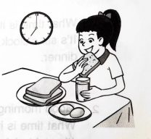 | B | 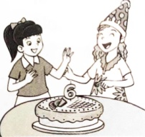 | 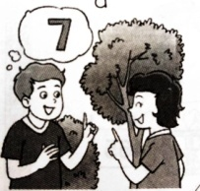  C |  | D | 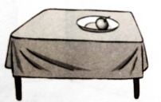 | E | 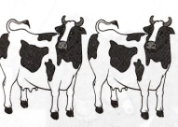
 | ( ) |  | ( ) |  | ( ) |  | ( ) |  | ( )
三、听录音，选出正确的译文，将序号填在题前括号内。（5分）
（ ） | 1. | A | 苏海和苏阳是姐妹。 | B | 苏海和苏阳是双胞胎。
（ ） | 2. | A | 看这三只狗。 | B | 看这些狗。
（ ） | 3. | A | 到了睡觉的时间了。 | B | 到了起床的时间了。
（ ） | 4. | A | 这是什么鸟儿啊！ | B | 多好看的鸟儿啊！
（ ） | 5. | A | 要吃这个热狗。 | B | 不要吃这个热狗。
四、听录音，选出合适的应答句，将序号填在题前括号内。（10分）
（ ） | 1. | A | OK, Miss Li. | B | It’s a window.
（ ） | 2. | A | I’m sorry. | B | No, thank you.
（ ） | 3. | A | Yes. It’s a rubber. | B | No. It’s a rubber.
（ ） | 4. | A | It’s on the desk. | B | It’s my book.
（ ） | 5. | A | I’m OK. | B | I’m eight.
- 听录音，填入所缺单词。
- Look at the______. How nice!
- I see a tall_____ under the tree.
- Is he_______ _________? —Yes, he is.
- What time is it? It’s_______ o’clock.
一、根据句意，选出与句中划线部分发音相同的词完成句子,填序号。（5分）
A. grandma | B. me | C. grandpa | D. breakfast
E. my | - black | - blackboard | - beside
1. | Welcome to ____ mother’s farm.
2. | That man is my ____, Nancy.
3. | It’s time for ____. Hurry up!
4. | -Guess, where is the desk? -Oh, it’s ____ the door.
5. | That ball is blue and ____.  书写部分 (15分)  - 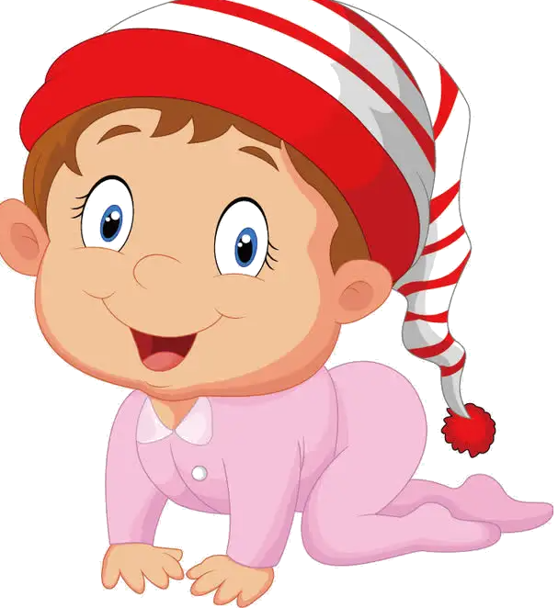根据图片或首字母提示写单词。（8分）  1. I have a sister. She’s ten months（月） old.  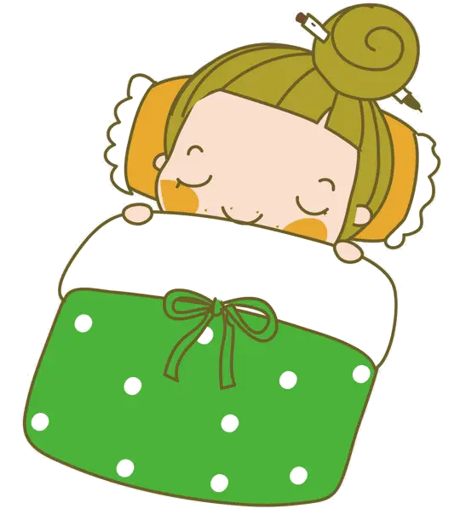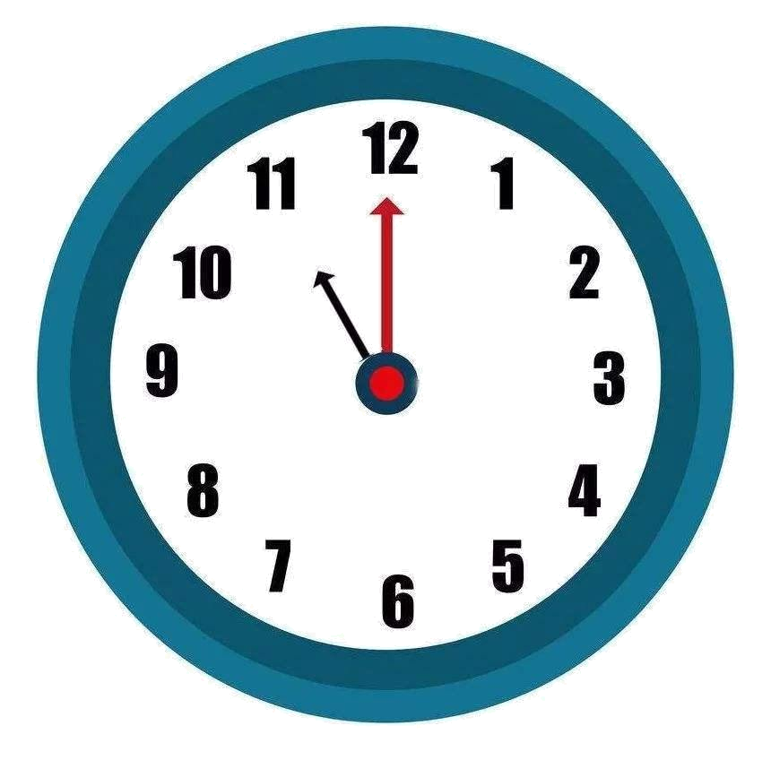  - It’s . It’s time for .  - 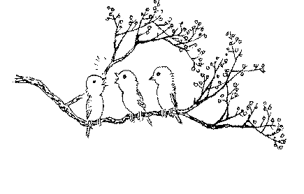-Open your books, please. - , Miss Li.  - I can see three in the tree.  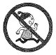  - Don’t in the library.  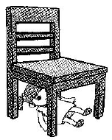  6.My doll is the .  二、选词填空，补全句子。  1.—What are________(that/these)?—_______(It’s/They’re) balls.  2._____ (He/She)is my grandpa.  3.Look at the bird. _______(How/What)beautiful!  4.Look! Liu Tao is_______(in/on) the tree.  5.It’s in______(me/my) schoolbag.  6._______(Who’s/Where’s) that man? He’s under the tree.  三、连词成句  1.old, sister, your,is how(?)  ______________________________________________  - eat, don’t, cakes, library, the in(.)  _______________________________________________  - like, would, you, blue, a, pencil(?)  _______________________________________________  - is, the, what, time, Tina(?)  ________________________________________________  - is, now, desk, bird, the, in, the(.)  ________________________________________________  根据所给图片及上下文提示，补全对话。  - What’s on the desk? It’s______ ________.  - ______ are these? They’re__________.  - ______ is the dog? ______ on the floor.  - Welcome to my_______. Are these ducks?  No, they’re_________.  - What are the fruits(水果) on the tree?  They’re_______ and_________
( ) | 1. | -What’s _____ over there? -It’s _____ English book.
 |  | A. that; a | B. this; an | C. that; an
( ) | 2. | -Where’s Lucy? -_____ in the library.
 |  | A. she’s | B. She’s | C. He’s
( ) | 3. | - Is this _____? - No. That’s my cousin.
 |  | A. my | B. your | C. you
( ) | 4. | Don’t _____ Bobby, Sam.
 |  | A. talk | B. listen | C. listen to
( ) | 5. | I can see some oranges _____ the tree.
 |  | A. in | B. on | C. at
( ) | 6. | It’s too hot. _____ the window, please.
 |  | - Close | - Don’t open | - Open
( ) | 7. | _____ is that boy? He is my _____.
 |  | - Who; twin brother | - Who; twin brothers | - Who ; twin
( ) | 8. | It’s six o’clock in the evening. It’s time for _____.
 |  | - dinner | - breakfast | - bed
( ) | 9. | -I’m eight. _____ you? -I’m eight, too.
 |  | A. How are | B. Who are | C. What about
( ) | 10. | Turn round and round. Don’t _____ to the ground.
 |  | A. falls | B. fall | C. to fall
- 阅读并选择方框内合适的选项，将相应的字母填在横线上，有多余选项。（10分）

A

- Wake up B. my skirt C. ducks D. read E. shout F. Welcome to
- Good morning! _____ our school.
- -Look at _____. -How nice!
- -_____, Taotao. Breakfast is read. -OK, Dad.
- -Five _____ are on the farm. -How cute!
- Don’t _____ in the classroom.

B

- They are twins. B. Let me have a look.
C. You look cute! D.This is a picture of my family.
E. And my mother is beside him. F. You are a boy.
Nancy: Mike, I want to know your family.
Mike: OK. 1. _____ .
Nancy: 2. _____ Are they your grandpa and grandma?
Mike: Yes. The two men are my uncles. 3. _____
Nancy: Is this man your father?
Mike: Yes. 4. _____
Nancy: They look young.（年轻的） What about the baby boy?
Mike: It’s me.
Nancy: Ha Ha! 5. _____

四、从右栏找出与左栏相对应的句子，填序号。（6分）
（ ）1. Would you like some milk? | - Yes, Miss Li.
（ ）2. Who are they? | - It’s two o’clock.
（ ）3. Are those pears? | - They are in your bedroom.
（ ）4. What’s the time ? | - Yes, they are.
（ ）5. Please stand up. | - Yes, please.
（ ）6.Where are my toy robots? | - They’re twin sisters.

五、将下列句子排列成一段完整的对话。（6分）

A. It's a toy bird.
B. Welcome to our toy museum.
C. What's this?
D. Is that a toy bird, too?
E. I'm sorry.
F. Wow! What a big robot! How cool!
G. Shh! Don't shout in the museum.
H. No, it isn't. It's a robot.

B |  |  |  | H

六、为对话选择合适的图片，将序号填在题前括号内。（8分）

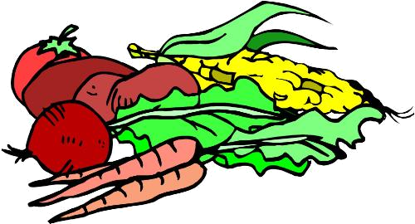
( ) 1.—Would you like some sweets? A.

—No, thank you.
—Drink some milk, please.
—Yes, please.

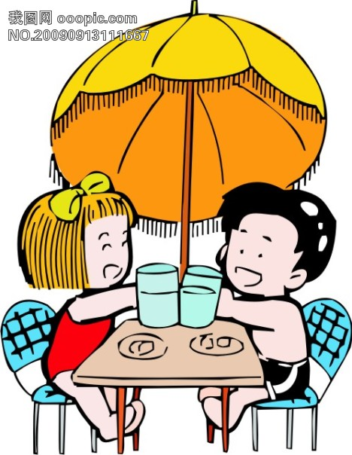
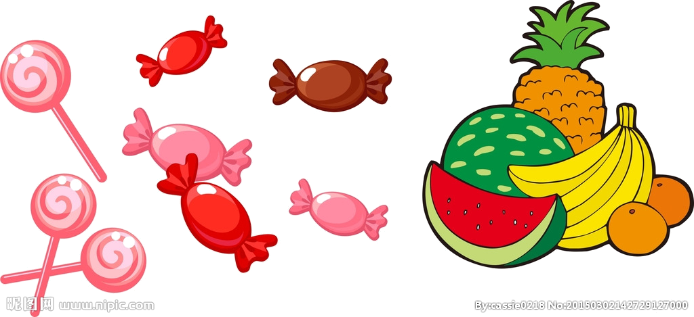
( ) 2.—Look at my pictures. B.
—How nice! This cow is lovely!
—Thank you. Are these chickens lovely, too?
—Yes, they are.
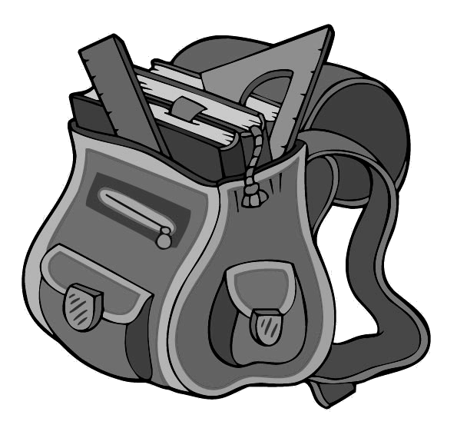
( ) 3.—What time is it? C.

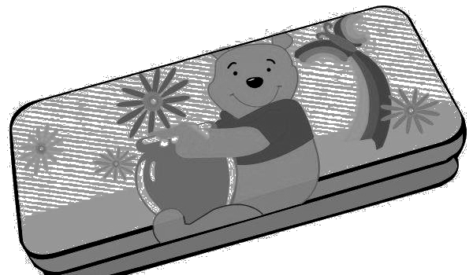
—It’s 12:00 o’clock. Time for lunch.

—What’s for lunch?
—Rice(米饭), duck and vegetables(蔬菜).
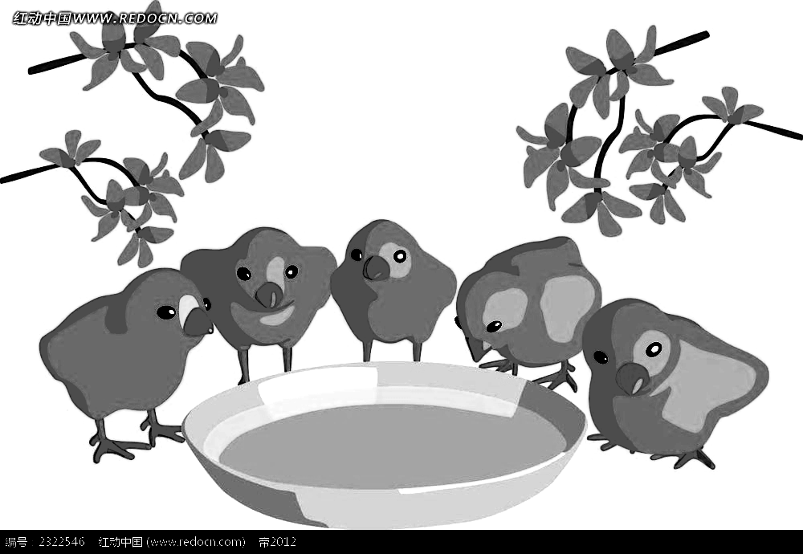
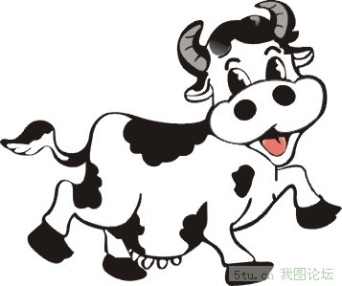
( ) 4.—This isn’t my pencil case. D.

—What colour is your pencil case?
—It’s green.
—Look! It’s beside my schoolbag. Here you are.
七、阅读理解，根据短文内容完成相应题目。（10分）
B. 阅读短文，判断下面表达是（T）否（F）正确。
Bill：Hello, Mike. Come and meet my new friend, Linda.
Mike: Nice to meet you, Linda.
( ) 1. Linda is Bill’s new friend.
( ) 2. Linda has four baby dogs.
( ) 3. The baby dogs are brown.
( ) 4. It’s time to feed the baby dogs.
( ) 5. Bill and Mike want to see the baby dogs.
Linda: Nice to meet you, too.
Bill: Linda has three baby dogs(狗).
Mike: What colour are they?
Linda: One dog is black.
Two dogs are brown.
Oh, time to feed(喂) the dogs now.
Do you want to see(看) my baby dogs?
Bill & Mike: Great!

