**六上Unit5测试卷**

班级_______ 姓名_______ 学号_______

**一、选出划线部分读音相同的选项。（1’x6=6’)**

( )1. A.cleaned B. talked C.looked D.worked

( )2. A.showed B.called C.named D.visit*ed*

( )3. A.work B.September C.today D.ago

( )4. A.shirt B.nurse C.her D.yesterday

( )5. A.litter B.centre C.were D.skirt

1. **词组翻译。（1’X10=10）**
2. 带人 6.in a restaurant
3. 在远足 7.eat some noodles
4. 请勿吸烟 8.Be careful
5. 在一家购物中心 9.in the forest
6. 寻找 10.around her
7. **选择题。(0.5x24=12’）**

( )1. Mr Green usually letters to his friends.

A.writes B.write C.wrote

( )2.--Does the sign ‘No ’？ --Yes,it does.

A.means,writing B.mean,write C.mean,writing

( )3. I know animals.

A.a lots of B.lot of C.a lot of

( )4. Someone smoking in the room. Can you it？

A.is,smells B.are,smell C.is,smell

( )5.You can’t take your juice the supermarket.

A.in B.into C.on

( )6.--Does Mike often kites at the weekends？

--No,but he kites with me last weekends.

A.fly,fly B.flew,flew C.fly,flew

( )7.Look at these signs. They we shouldn’t the trees.

A.means,climb B.mean,climbing C.mean,climb

( )8.The near the window are funny.

A.signs B.sign C.a sign

( )9.The book isn’t on the desk. It there a moment ago.

A.were B.was C.is

( )10.Mary can’t her bag. Now she .

A.find,is looking for B.look for, is finding C.find,look for

( )11.What this ? It ‘No smoking’.

A.do,mean,means B.does,means,means C.does,mean,means

( )12.This sign“No smoking” you can’t smoke.

A.mean B.means C.meaning

( )13.What the words mean？

A.does B.do C.is

( )14.No parking means we shouldn’t .

A.ride our bikes in the park B.take a bus C.stop your car here

( )15. that sign interesting？ Yes,I think so.

A.Does B.What’s C.Is

( )16.“Keep off the grass”means we walk on the grass.

A.can B.shouldn’t C.must

( )17.Mr Green usually his friends when he was young.

A.writes B.is writing C.wrote

( )18.Why we swim in the river？--Can’t you see the sign “ No swimming”there？

A.can B.should C.can’t

( )19.John is twenty years old,but he has only five birthdays. Why？

Because he was born(出生) .

A.at night B.five years ago C.on February 29

( )20.I called yesterday afternoon. But she in.

A.she,isn’t B.her,wasn’t C.her,isn’t

( )21.We take the hot dogs the food shop.

A.should,in B.shouldn’t,into C.can,at

( )22. interesting book I read yesterday！

A.How B.What an C.How an

( )23.Ming Ming knows public signs.

A.a lot B.a lot of about C.a lot about

( )24.You can’t speak loudly run in the classroom.

A.and B.to C.or

**四、用所给单词的适当形式填空。(1’x24﹦12’)**

1.Five years ago,he (can)ride a bike.

2.It yesterday. There (be) a lot of ( rain) yesterday evening.

3.What the sign (mean)？

4.Mike’s grandpa likes (listen) to the radio.

5.You should (do) your homework every day.

6.The sign on the wall (mean) Danger.

7.Mike’ family (be) very happy on that farm.

8..Look.The old man (smoke).

9. your father (write)letters to you yesterday？

10.My teacher (say)to the girl just now.

11.They (eat) a big lunch last holiday.

12.“No ”means you shouldn’t (litter)here.

13.Look！ The two men (walk) on the grass.

14.What are (this)？

15.It was (rain) this morning.

16.Can you (fly) kites, Mike？

17.It’s time to (have) our lunch.

18.Please don’t (bring) these cakes to school.

19.My mother often (write) letters in the evening.

**五、根据课文和首字母提示填空。(1’x19=19’)**

Mike,Helen and Tim are at a s c .

Mike﹕Be c ,Tim!

Helen﹕Can you see that s ?

Tim﹕What does it m ?

Helen﹕It m the floor is w .Then,they see a juice shop.

Helen﹕Do you want s j ?

Mike﹠Tim﹕Yes,please.

Tim﹕Here’s a s . What does it mean, Mike ?

Mike﹕It means you can’t l here. There is a b .

(Helen w to go in . Now they are eating some n in a restaurant.)

Mike﹕You can’t take your juice i the shop, Helen.

Tim﹕Can you see that sign？It means you can’t eat o drink there.

Helen﹕I’m sorry. Helen﹕Is someone s ? I can s it.

Tim﹕Please don’t s here. Can you see that sign？ It means you can’t smoke here.

Man﹕OK, sorry！

**六、选择适当的词组，并按照其适当的形式完成句意。(1’x7=7’)**

look out of make a sentence public places

eat or drink tired and thirsty litter keep quiet

1.To keep our school clean and tidy . You shouldn’t .

2.I the door. It was raining heavily.

3.There are lots of signs in .

4.The teacher asks﹕Can you with the new words？

5.Look at the sign. You can’t here.

6.I am . Let’s go to the juice shop.

7.Let’s in the cinema when you watch a film.

**七、首字母填空。(0.5’x14=7’)**

1.Be c . There is a bus in front of you.

2.My teacher t me this story yesterday evening.

3.Can I t my pets into the park？

4.There are lots of signs a us. So we should follow the signs.

5.What’s the w like today？

6.I can hear s singing in the classroom. Who is it？

7.We can’t s in the cinema. It’s bad or others.

8.The bus is broken(坏了). We get off the bus and have to w on.

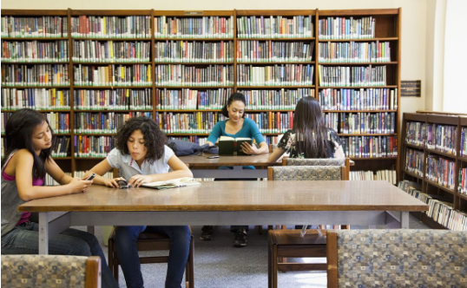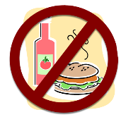**八、看图联系上下文补全对话。**  **图1**

1.A﹕What they in the library now？

B﹕They magazines.

So they can’t ______________ in the library.

2.A﹕Excuse ,sir. I walk the grass？

B﹕No,you .

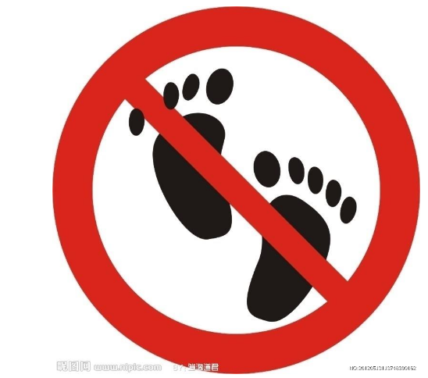A﹕Why? **图2**

B﹕Look, it ‘ the grass.’

A﹕Oh,I .Thank you.

**九、选用方框中所给句子完成对话，有一句是多余的,填序号。**

A.By the way,why did you call me？

B﹕How long did you stay there？

C﹕Would you like to come to my birthday party？

D﹕Speaking！

E﹕How was your travelling？

F﹕Where did you go？

A﹕Hello！May I speak to Mike？

B﹕

A﹕Hi,Bill！This is Mary speaking.

B﹕Hello！What’s up？

A﹕I called you yesterday, but nobody answered the telephone.

B﹕I went to the Word on Water with my parents.

A﹕Really？

B﹕It was great. We saw the animal show. It was very great fun.

A﹕That sounds interesting.

B﹕

A﹕Oh,tomorrow will be my birthday.

B﹕Yes,I’d love to. Thanks a lot.

A﹕You are welcome.

1. **按要求完成句子。**

1.Helen watched TV last night. (对划线部分提问)

Did Helen last night？

1. Liu Tao went to the Bund. (对划线部分提问)

did Liu Tao ？

1. He eats a cake every day. (用last Sunday 替换every day)

He a cake .

1. I caught some fish this afternoon. (改为一般疑问句)

You fish this afternoon？

十一、**完形填空**

We know a lot about 1 .They 2 different 3 .We 4 walk 5 the grass. We should 6 in the classroom. The sign“Danger” 7 we 8 go in it. In the cinema or other places,we should not 9 things. In the library or reading room,we should read books 10 .

( )1. A.public sign B.publics sign C.public signs

( )2. A.mean B.means C.meaning

( )3. A.things B. the thing C.thing

( )4. A.should B.can C.can’t

( )5. A.in B. on C.to

( )6. A.keep off the grass B. make noise C.be quiet

( )7. A.is mean B. mean C.means

( )8. A. must B. can C.should not

( )9. A. litter B.no littering C.touch

( )10. A. quiet B.quietly C.be quiet