Unit8 At Christmas 课堂练习
First,选择合适的图片
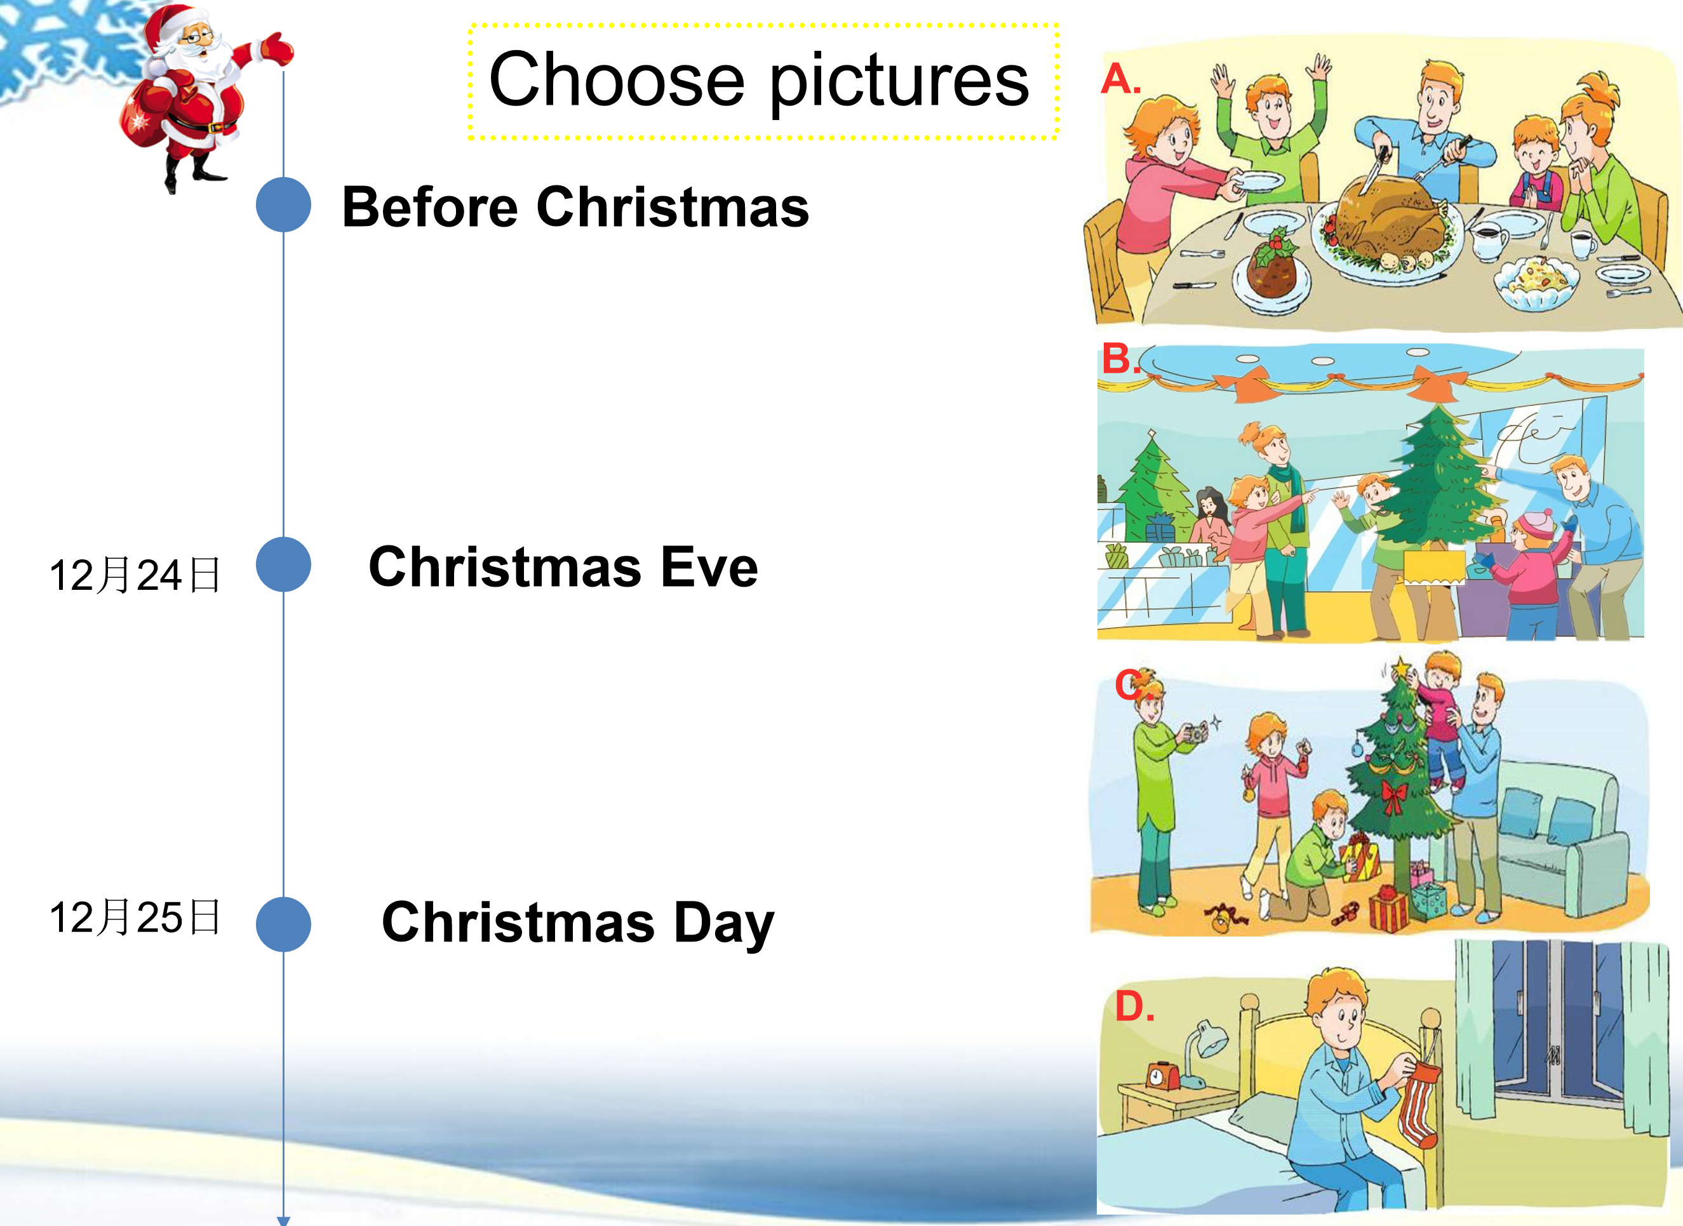
Next,listen and tick
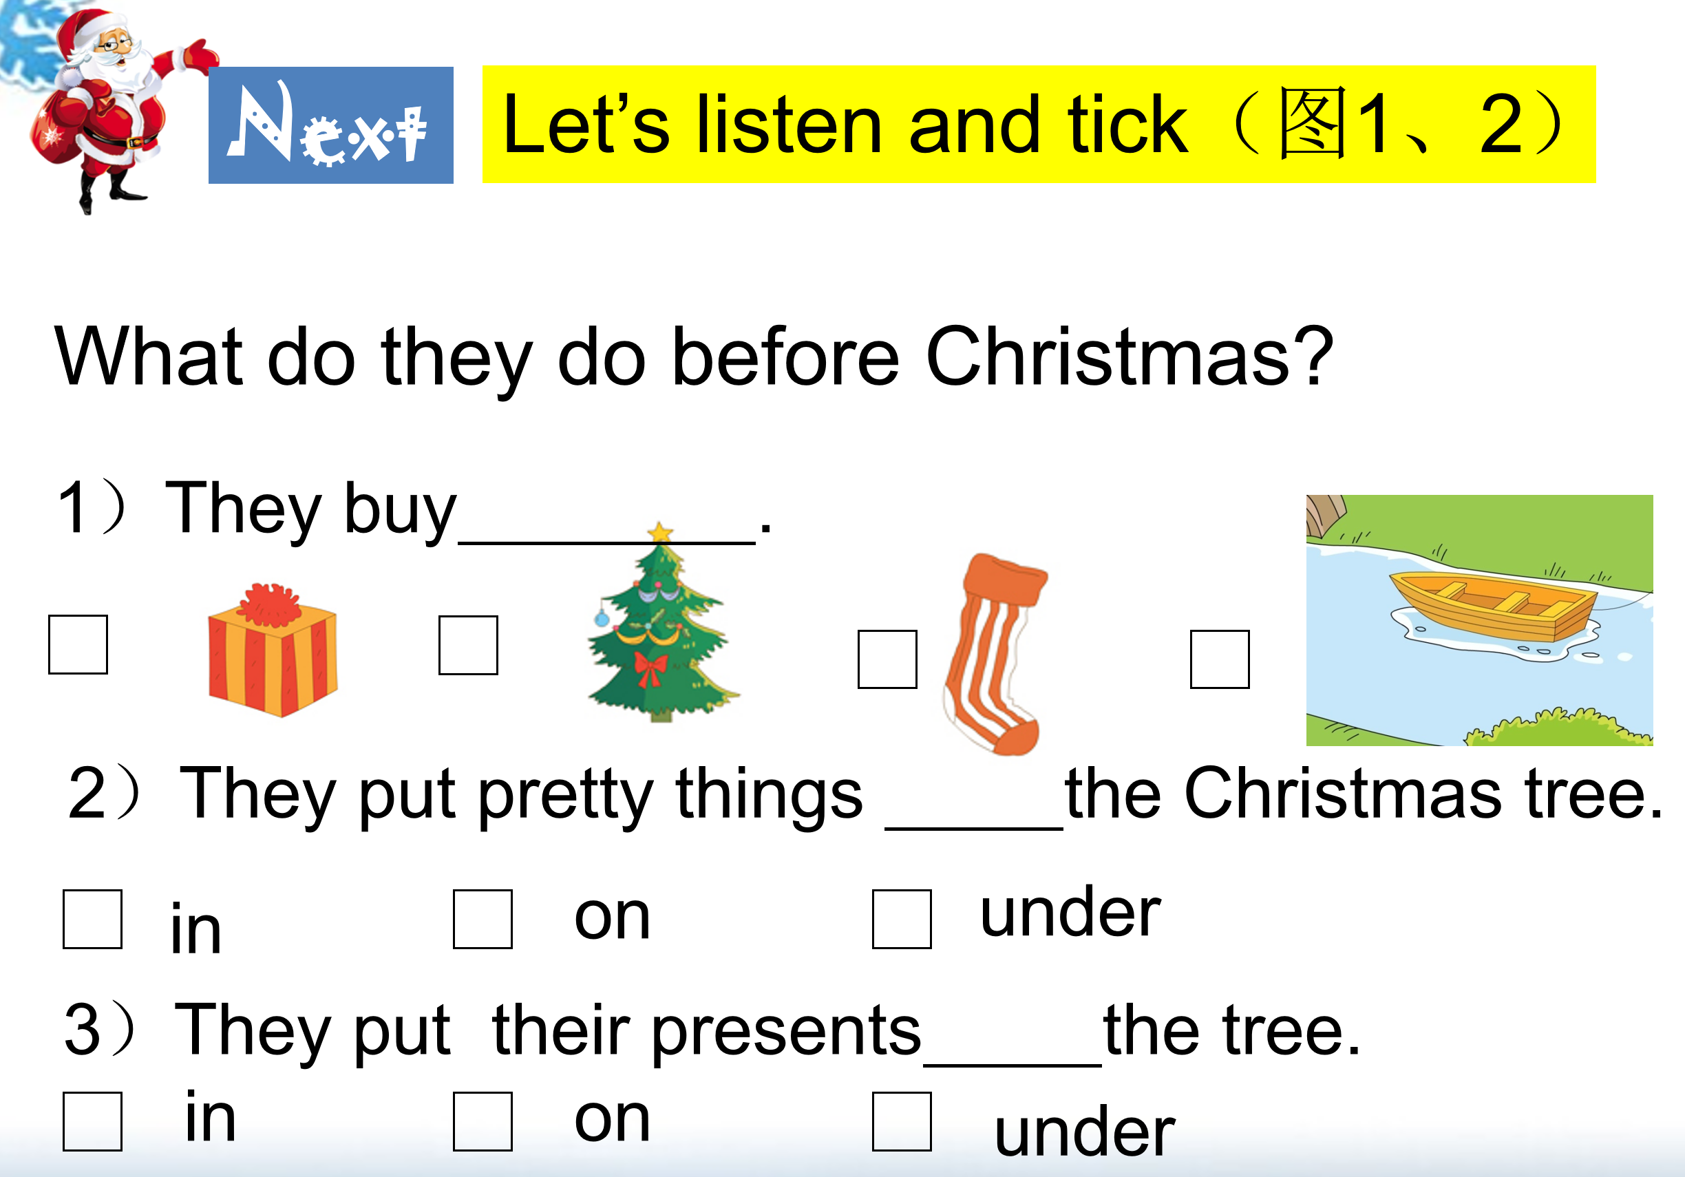
Then,read and complete
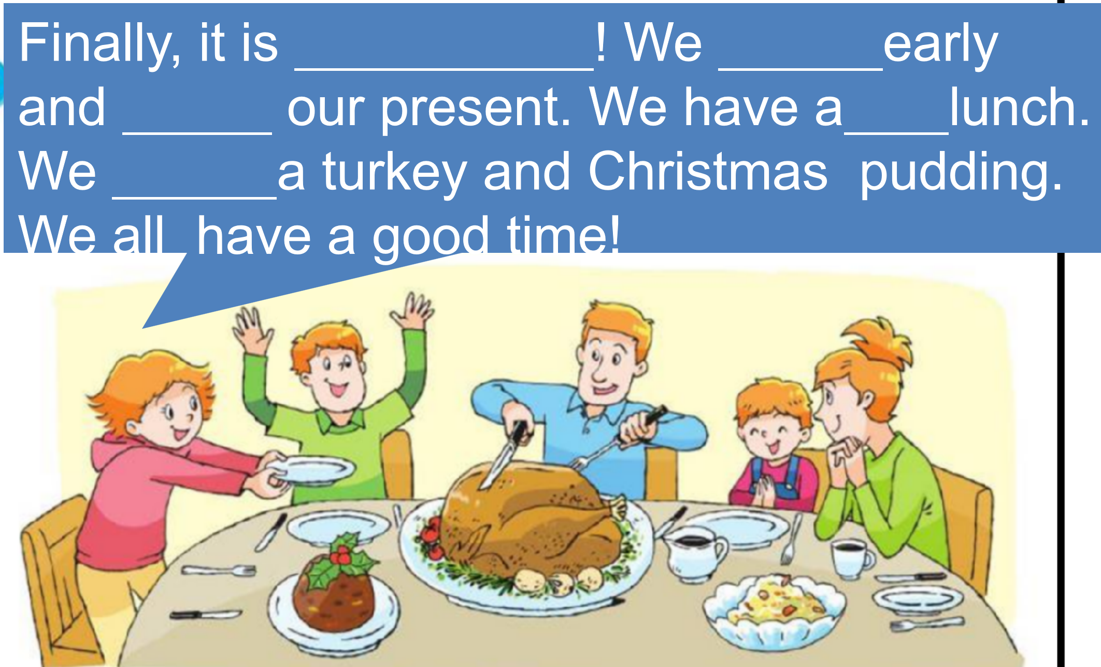
Finally,Make a Christmas plan
My Christmas plan
