Unit 4 I can play basketball
班级__________ 姓名_____________
难度：
一、判断下列单词画线部分发音是否相同。相同打“√”，不相同打“×”。
( )1. A. six B. this ( )2. A. football B. father
( )3. A. hot B. horse ( )4. A. four B. for
二、写出下列缩写的完整形式。
1. it’s=__________________________ 2.can’t=_______________________
3. he’s=_________________________ 4. they’re=_____________________
5. don’t=_________________________ 6. that’s=______________________
7. let’s=__________________________ 8. what’s=_____________________
三、英汉互译。
1.玩得好________________________ 2. Don’t be sad!________________
3. 试一试_______________________ 4.I can’t swim either._____________
5. 打篮球_______________________ 6.What about…?________________
7. 多少__________________________ 8. fifteen footballs _______________
四、判断下列句子意思是否相同。相同打“√”，不相同打“×”。
( )1. a. Can you play basketball? ( )2. a. Can I have a try?
b. Do you like basketballs? b. Can I have a look?
( )3. a. What time is it? ( )4. a. Goodbye, Mum.
b. What’s the time? b. See you, Mum.
( )5. a. What about a cake? ( )6. a. What do you like?
b. Would you like a cake? b. What would you like?
五、单项选择。
( )1.-----______ you play football? -----Yes, I ______.
A. can, can B. Can, can’t C. Can, can
( )2.-----______ ? -----No, I can’t.
A. Can you swim? B. What can you do?
C. Can you swim or skate?
( )3.I can’t fly _____________.
A. to B. too C. either
( )4.----- Can Mike swim? -----______.
A. Yes, I can B. Yes, she can C. No, he can’t
( )5.-----I can’t swim. ----- ______.
A. Don’t be sad! B. I can swim C. Haha
六、用所给词的适当形式填空。
1. Tweet, tweet. I ______________(can not ) fly.
2.This is ____________(I ) mother.
3. Look at my toy cars. ____________(it’s) nice!
4. Do you have ______________(some) bananas?
5. Do you like ______________(dog), Mike?
6.How many ________________(sticker) do you have?
7. Can you _____________(swim), Yang Ling?
8. I have a mango and ___________(a) orange.
七、根据实际情况，完成下列表格。并把自我介绍补充完整。（在表格内打“√”。）

 | play basketball | play football | swim | jump | skate
can
can’t
Hello, boys and girls. Look, I can___________________________________
_____________________________________________________________.
But I can’t______________________________________________________
难度：
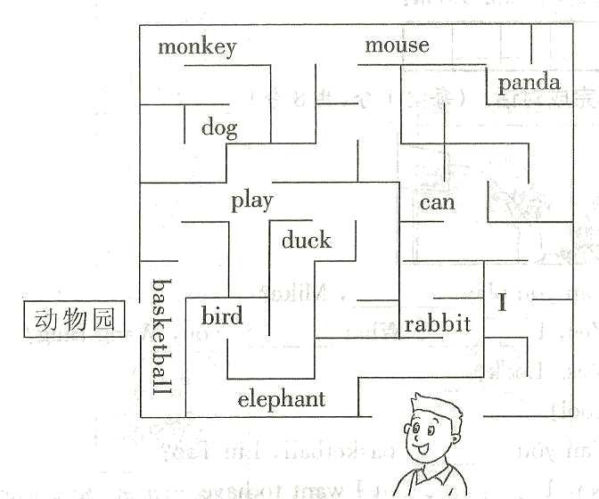
Wang Bing 要去参观动物园了，可他必须把沿途经过的单词组成一句完整的话，才能达到那里。小朋友，来和他比赛吧，看谁先走出迷宫哦！

走出迷宫正确的路是____________
____________________________

