|  |  |  |  |  |  |  |
| --- | --- | --- | --- | --- | --- | --- |
| 长方形的长（米） |  |  |  |  |  |  |
| 长方形的宽（米） |  |  |  |  |  |  |
| 长方形的面积（平方米） |  |  |  |  |  |  |

：

1. **一个音乐钟，每隔一段相等的时间就发出铃声。已知上午9：00、9：40、10：20、11：00发出铃声，那么下面哪些时刻也会发出铃声？**

13：00 14：00 15：40 16：00

|  |  |  |  |  |  |  |  |
| --- | --- | --- | --- | --- | --- | --- | --- |
| 9：00 | 9：40 |  |  |  |  |  |  |
|  |  |  |  |  |  |  |  |

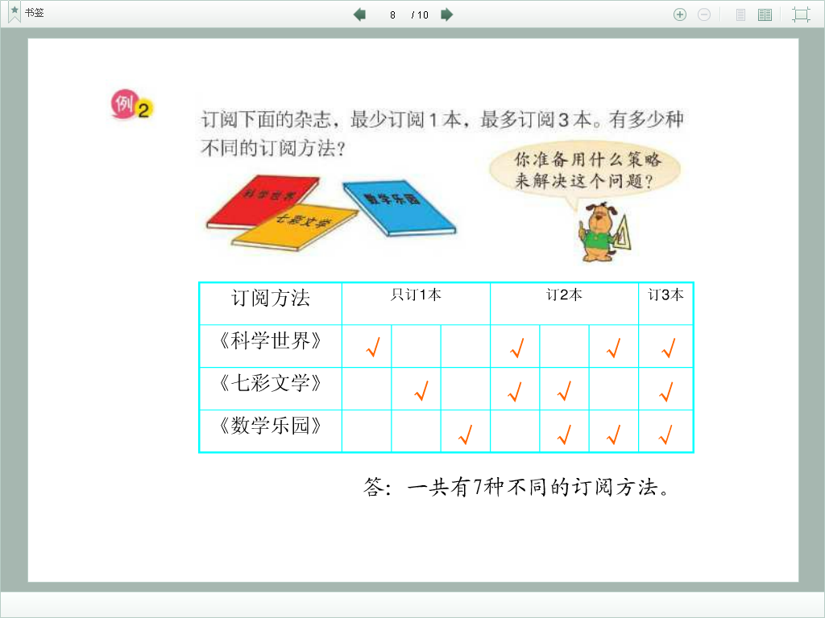

2

|  |  |  |  |  |  |  |  |
| --- | --- | --- | --- | --- | --- | --- | --- |
| 订阅方法 | 只订1本 | | | 订2本 | | | 订3本 |
| 《科学世界》 |  |  |  |  |  |  |  |
| 《七彩文学》 |  |  |  |  |  |  |  |
| 《数学乐园》 |  |  |  |  |  |  |  |

3

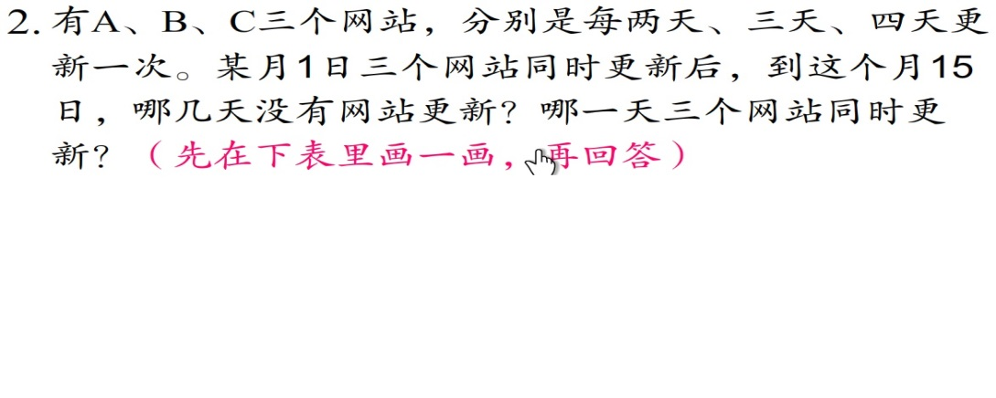

|  |  |  |  |  |  |  |  |  |  |  |  |  |  |  |  |
| --- | --- | --- | --- | --- | --- | --- | --- | --- | --- | --- | --- | --- | --- | --- | --- |
| 日期 | 1 | 2 | 3 | 4 | 5 | 6 | 7 | 8 | 9 | 10 | 11 | 12 | 13 | 14 | 15 |
| A网站 |  |  |  |  |  |  |  |  |  |  |  |  |  |  |  |
| B网站 |  |  |  |  |  |  |  |  |  |  |  |  |  |  |  |
| C网站 |  |  |  |  |  |  |  |  |  |  |  |  |  |  |  |

4、**用24个边长1厘米的正方形拼成长方形，有多少种不同的拼法，拼成的长方形周长最大是多少？**

|  |  |  |  |  |  |  |
| --- | --- | --- | --- | --- | --- | --- |
| 长方形的长（米） |  |  |  |  |  |  |
| 长方形的宽（米） |  |  |  |  |  |  |
| 长方形的周长（米） |  |  |  |  |  |  |