小学英语四年级（下）Unit 3-4单元测试
成绩_____________
听力部分（30分）
一、根据所听内容，选出你所听到的单词。（10%）
( ) 1. | A. rabbit | B. rubber | C. brother
( ) 2. | A. 5:15 | B. 5:50 | C.4:15
( ) 3. | A. copybook | B. English book | C. storybook
( ) 4. | A. kite | B. bike | C. like
( ) 5. | A. car | B. cap | C. cat
( ) 6. | A. dog | B. bag | C. doll
( ) 7. | A. 98 | B. 68 | C. 38
( ) 8. | A. Tuesday | B. Thursday | C. Wednesday
( ) 9. | A. lake | B. late | C. cake
( ) 10. | A. much | B. match | C. lunch

1. | 2. | 3.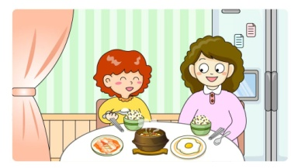
( ) | ( ) | ( )
4. 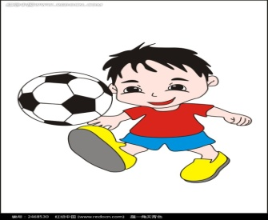 | 5.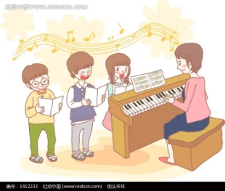 | 6.
( ) | ( ) | ( )
二、根据所听内容，给下列图片标上序号。（6%）
三、根据所听到的问题，选出最佳答句。（6%）
( ) 1. | A. It’s six thirty. | B. At six twenty.
( ) 2. | A. I can see a tiger. | B. I can see some books.
( ) 3. | A. I like English. | B. I like drawing.
( ) 4. | A. Yes, it’s easy. | B. Yes, it is.
( ) 5. | A. I can see a TV. | B. Yes, I can.
( ) 6. | A. No, I don’t. | B. Good idea.

四、根据所听内容，完成下列句子，每空一词。（8%）
1. A: What day is it today?
B: It’s _____________. Let’s go to the park. I can draw some _____________.
2. A: _____________ do you do your homework?
B: At seven _____________ in the _____________.
3. A: What _____________ do we have this _____________?
B: We have _____________ and Maths.
笔试部分（70分）
一、选出与划线部分单词属于同类的单词。（6%）
( ) 1. | Look! This is our new school.
 | A. library | B. lesson | C. lion
( ) 2. | I have lunch at twelve.
 | A. night | B. home | C. breakfast
( ) 3. | I can make a fruit salad.
 | A. sea | B. noodles | C. yellow
( ) 4. | My grandfather is sixty years old.
 | A. thirsty | B. fifteen | C. home
( ) 5. | The bird is in the desk.
 | A. on | B. go | C. come
( ) 6. | I can play basketball very well.
 | A. door | B. basket | C. football
二、从下列句子的单词中，找出与所给单词划线部分读音相同的单词。（9%）
1. Don’t skate. Come and make a cake.
grape ______________ ______________ ______________
2. I can see a green tree over there.
me ______________ ______________ ______________
3. There is a red pen on the desk.
bed ______________ ______________ ______________
- 单项选择。（20%）
（ ） 1． | What lessons do you have this afternoon?
 | A．in | B．on | C．/
（ ） 2． | Boys and girls, is the first day of a week.
 | A．Monday | B．Sunday | C．Saturday
（ ） 3． | What do you have Tuesday morning?
 | A．subjects; in | B．lesson; on | C．lessons; on
（ ） 4． | Welcome back home.
 | A．/ | B．to | C．for
（ ）5． | watch TV. It’s time for bed.
 | A．Can’t | B．Don’t | C．Aren’t
（ ）6． | —Who are we? —Tom, Jack and .
 | A．me | B．I | C．my
（ ）7． | Let’s over there.
 | A．to draw | B．drawing | C．draw
（ ）8． | Can you see the boat the river?
 | A．on | B．in | C．under
（ ）9． | You can see trees at my school.
 | A．lot of | B．a lot | C．a lot of
（ ）10． | Can you draw ?
 | A．they | B．them | C．their
四、用括号中所给单词的适当形式填空。（6%）
1. I can _________ (draw) pictures.
2. She _________ (have) a nice dress.
3. I like _________ (cake).
4. These are tall _________ (tree).
5. How many _________ (subject) do you have this term?
6. Art and English _________ (be) fun.
五、从方框中选择合适的句子完成对话，将序号填在横线上。（5%）
A: Hello, Billy. This is Tom. _______________
- When do you come home?
- Would you like to swim?
- What about this evening?
- See you at six thirty.
E. Where are you?
B: I’m at the snack bar.
A: _______________
B: At four.
A: _______________
B: Yes, but I want to watch cartoons at four thirty.
A: _______________
B: OK. How about six thirty?
A: All right. _______________

- 连词成句。（10%）
1．lessons, you, what, on, do, Monday, have （?）
2．don’t, any, I, lessons, today, have （. ）
3．in, you, can, what, the, see, box （? ）
4．football, I, the, in, play, playground（. ）
5. lesson, I, a, have, Friday, swimming, on (.)
七、阅读短文，选择正确答案。（10%）
Hi, my name is Mary. I live in a big house with my parents and my brother. My father is a doctor and my mother is a teacher. They don’t work on Saturdays and Sundays. They like watching TV on Saturdays. And they like cooking too. They cook nice food for my brother and me on Sundays. My brother likes playing the guitar, but I don’t. I like playing the piano. In the evening, I usually play the piano for my father and mother. I love my family and they love me too.
（ ） 1．There are four people in the family.
（ ） 2．Mary’s parents don’t work on Saturdays but they work on Sundays.
（ ） 3．Mary’s parents usually cook nice food on Saturdays.
（ ） 4．Mary’s brother likes playing the piano.
（ ） 5．This is a happy family and they love each other（互相）.

八、根据提示，写几句话，帮助王斌做一个自我介绍。（4%）
Hi, I’m Wang Bing. _________________________(我八点钟上学).I have 12 subjects at school. _________________________ (我喜欢英语和美术). _________________________ (今天是星期五). I don’t have any lessons. I go to the park. _________________________ (我能看见一座小山和一条小河). Look! I can draw them well.
小学英语四年级（下）Unit 3-4单元测试
听力稿
一、根据所听内容，选出你所听到的单词。（10%）
1. A: What can you see over there? B: I can see a rabbit.
2. I usually go home at five fifteen.
3. A: Is this your English book? B: Yes, it is.
4. I can ride a bike.
5. Whose cap is it?
6. Look at this lovely doll.
7. My grandfather is 68 years old.
8. What lessons do you have on Tuesday afternoon?
9. There is a boat on the lake.
10. What’s for your lunch?

二、根据所听内容，给下列图片标上序号。（6%）
1. Today is Monday. I have a Music lesson.
2. I get up at seven every day.
3. I usually play football with my friends after school.
4. I have a skating lesson on Sunday.
5. Time to go to bed. Don’t watch TV, Tom.
6. A: When do you have breakfast? B: At seven.

三、根据所听到的问题，选出最佳答句。（12%）
1. When do you go to school?
2. What can you see in the classroom?
3. What subjects do you like?
4. Is it difficult?
5. Can you see a TV in the room?
6. Let’s draw a big tree.

四、根据所听内容，完成下列句子，每空一词。（12%）
1. A: What day is it today?
B: It’s Thursday. Let’s go to the park. I can draw some flowers.
2. A: When do you do your homework?
B: At seven forty-five in the evening.
3. A: What lessons do we have this afternoon?
B: We have Chinese and Maths.

