**Unit5 Our new home课堂练习**

1. 

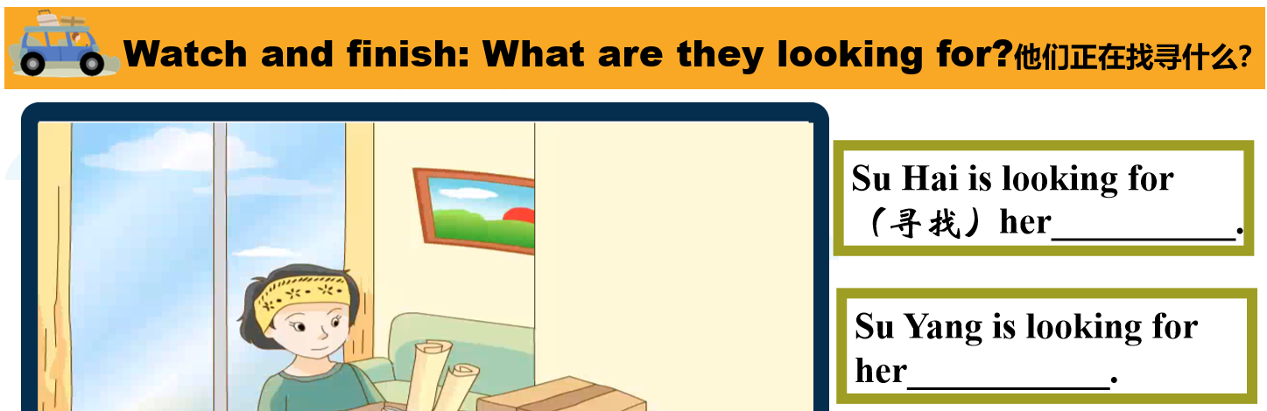

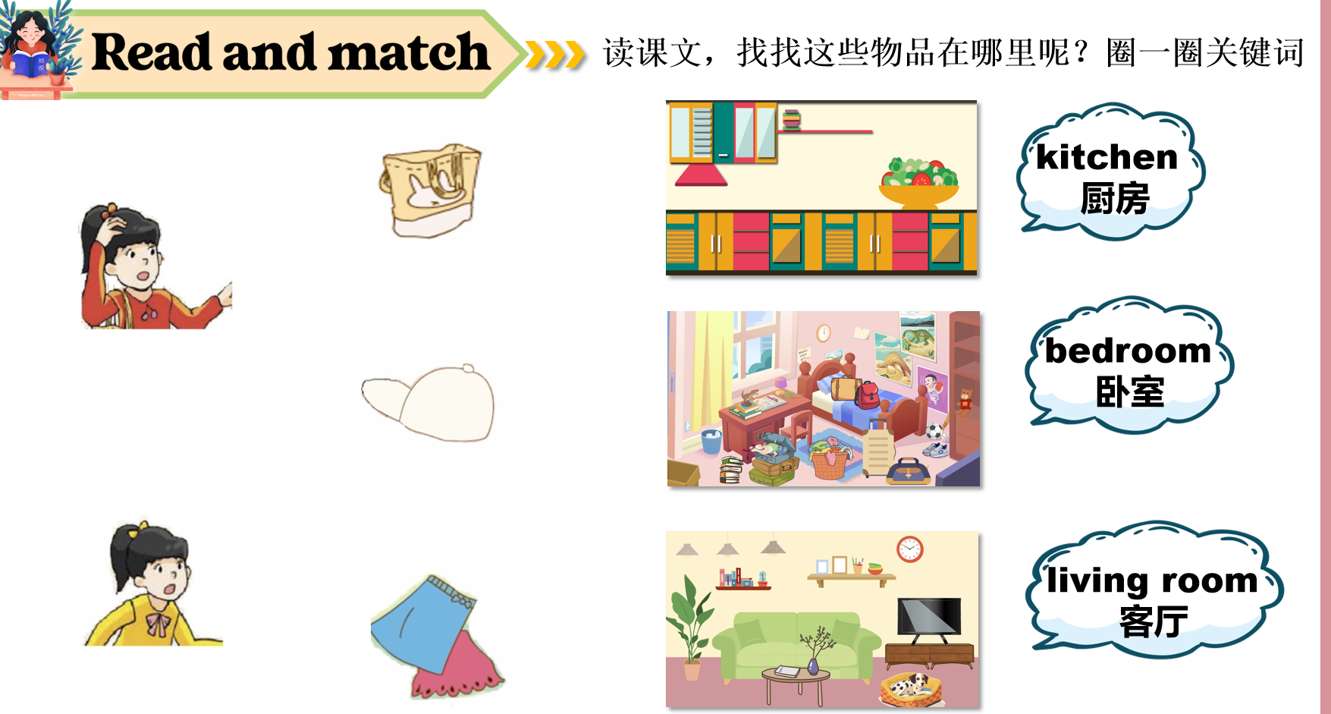

四、

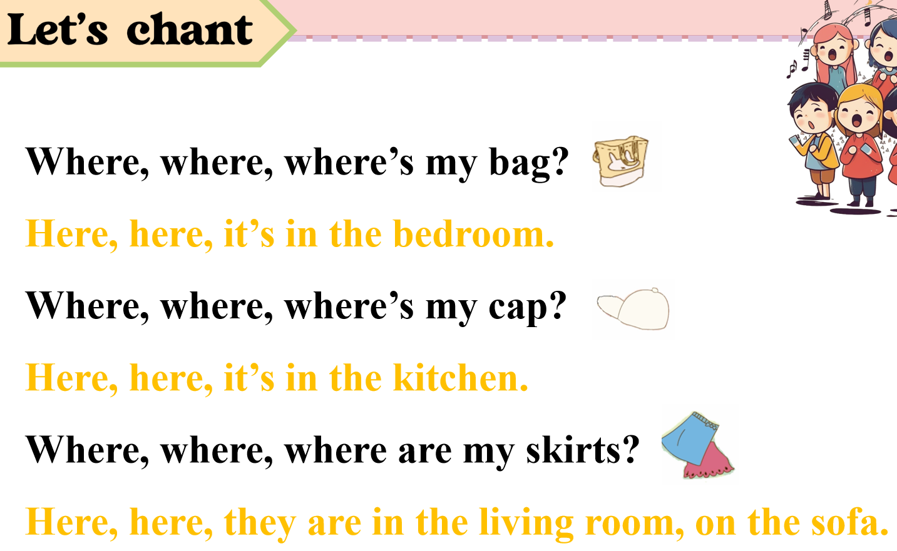

五、

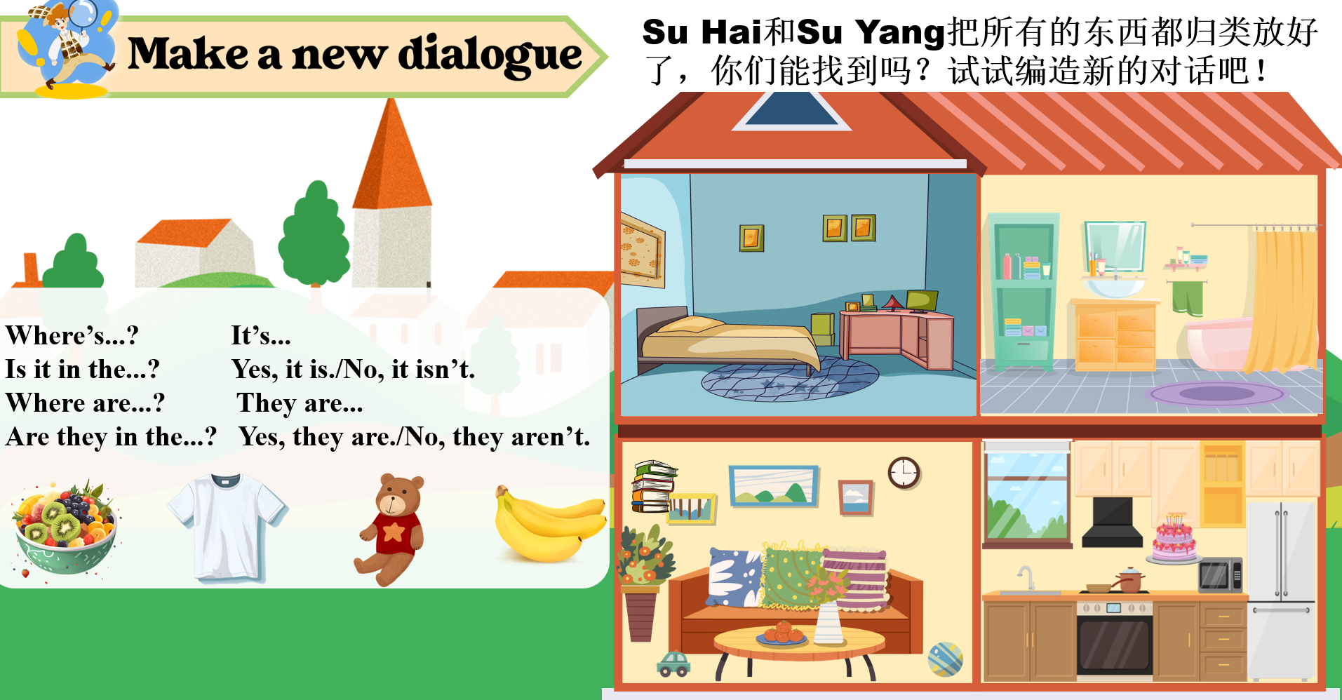

六、

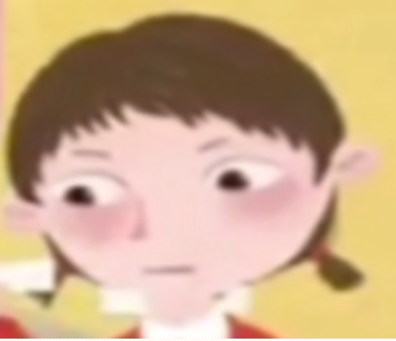绘本：Where are my toys?(Watch and answer)

What’s missing?什么东西弄丢了？

Where are they?