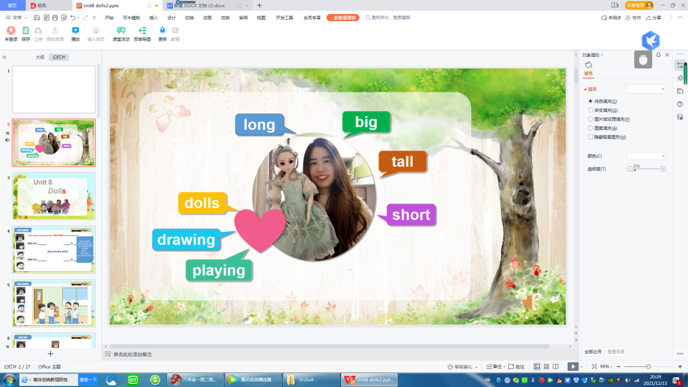
Step 1 Before learning
1 Now I’m your new teacher.
Do you want to know more about me.
Let me show you.
Now listen. (Chant)
Hi, everybody, look at me.
My hair is long.
My eyes are big.
I’m not tall.
I’m not short.
I love dolls.
I love drawing.
And I love
playing with them.
Do you want to join me?
2 Just now I said“What is long？” Ss ： Your hair.
Yes. My hair is long. 出示词卡1“hair” 翻转词卡1 “My hair”
3 面对一个学生，Look, my hair is long and brown . But your hair is short and black.
出示词卡“short” 翻转词卡1 “Your hair”
4 面对其他学生，Look, his hair is short and black. 翻转词卡1 “His hair”
5 指向更多学生，Look, his hair is short and black. Look, ...too. Look, ...指向一个女生。
Can we use “his”? We should say... 翻转词卡1 “Her hair”
Her hair is short .(too) Her hair is long .(too) 举例2~4个
6 Just now I said“What are big？” Ss ： Your eyes.
Yes. My eyes are big. 出示词卡2“eyes” 翻转词卡2 “My eyes”
7 Look, this is an eye. And this is my right eye. This is my left eye.
My eyes are big. But my doll’s eyes are bigger than me. They’re big and bright.
You know I love dolls. They are nice. Let’s watch.
Do you like dolls?
8 Today let’s learn Unit 8 Dolls
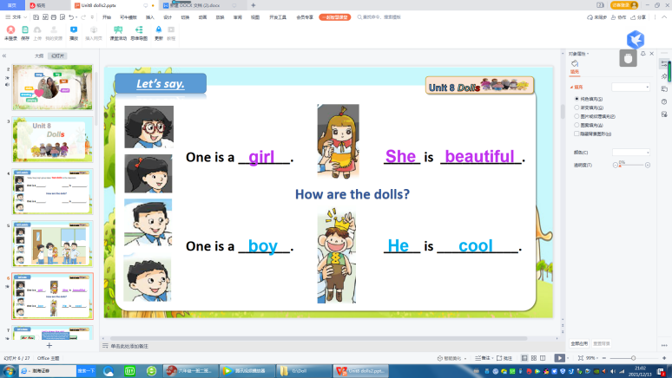
Step 2 Story time
1 Yang Ling and her friends love dolls too.
Today Yang Ling’s group takes two dolls to the classroom.
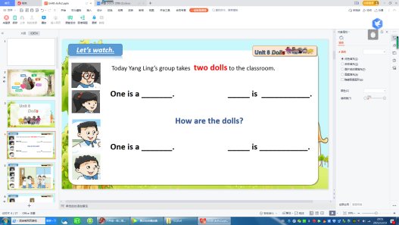
One is a ...
The other is a ...
How are they?
Let’s watch the cartoon
After watching the cartoon,
One is a girl. How is the girl? She is beautiful.
The other is a boy. How is the boy He is cool.
The boy is cool. Why? ...crown
So, he is a ... king三会词
2 You know I love dolls and I love drawing.
Now let me draw the girl. Can you help me?
Now, please don’t look at your book. Let me see who has a good memory.

First, let me draw her face. How is her face?
Fat？Thin? Round? Square? 粘贴词卡3“Her face” 粘贴词卡“round”
Second, let me draw her hair. How is her hair? ... 粘贴词卡1“Her hair” 粘贴词卡“long”
Next, let me draw her eyes. How are her eyes? ... 粘贴词卡2“Her eyes” 粘贴词卡“big”
Then, let me draw her nose. ... How is her nose? 粘贴词卡4“Her nose” 粘贴词卡“small”
After that, let me draw her mouth. How is her mouth? 粘贴词卡5“Her mouth” 粘贴词卡“small”
At last, let me draw her body and clothes?
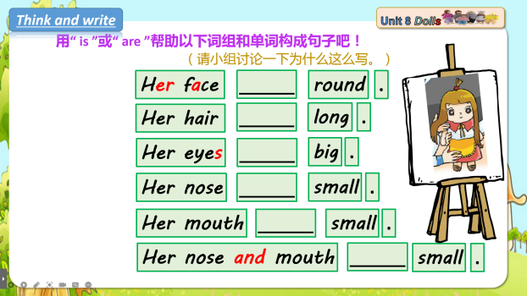
Ta-dah...is she nice?
3 Can you describe the doll?
Before describing it, please use “is” or “are” to finish
the sentences. Try to think why you use “is” or “are” here.
Let’s read together.
Can you describe it like this... (看黑板描述)
Look at this doll.
She is ...
Her face ...
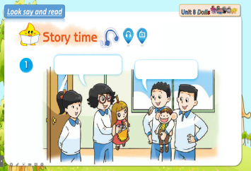
...
Her nose and mouth ...

4 Do you remember whose doll she is?
Yes. It’s Yang Ling and Su Hai’s.
出示图片。
5 Now they are showing their doll to Liu Tao and Wang Bing. Let’s read. 跟读课文

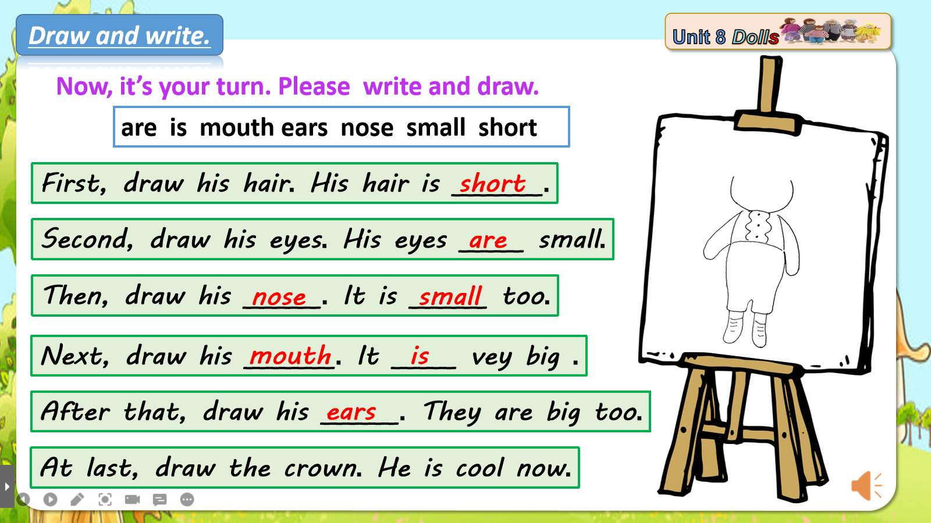
6 Now It’s your turn. Please write and draw . 学习ears
Who can draw here on this paper?
Who can stick the phrases and words on the blackboard?
画一画并选词填空。
Can you describe the boy?
Do you want to design a doll?
Let’s design a doll in group.

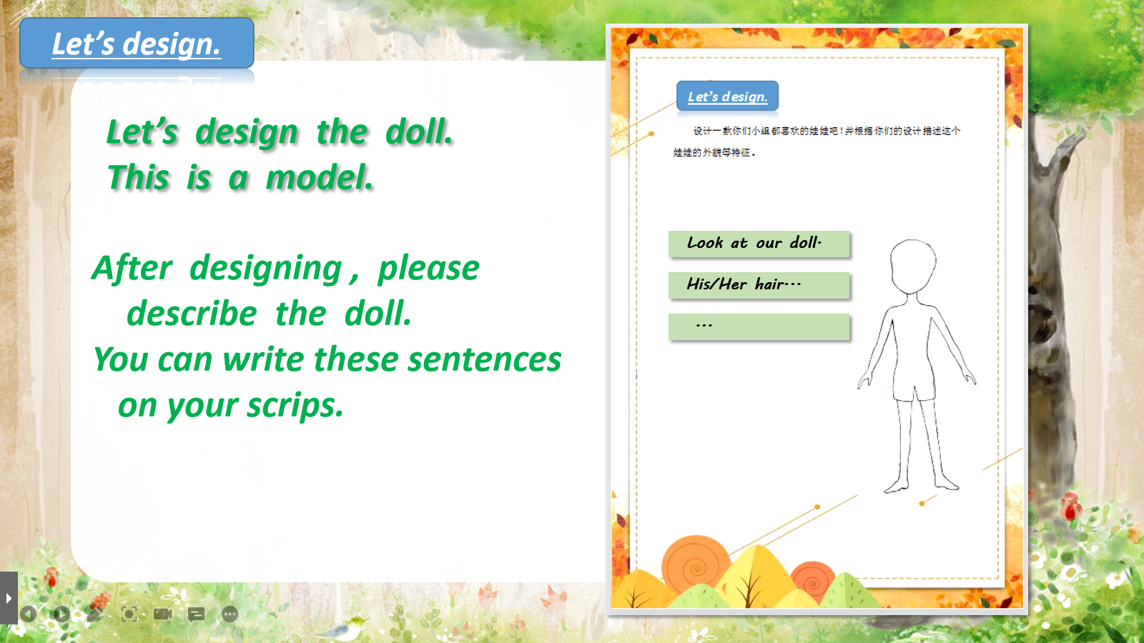
Step 3 Let’s design.
We can design a doll like this. 观看视频
Here’s a model.
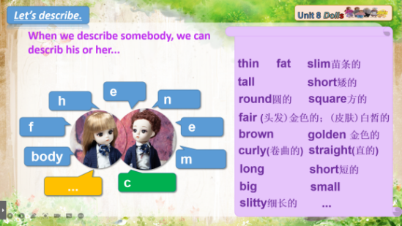
After designing , please describe the doll.
You can write the sentences on your scrips.
Before describing, let’s think.
When we describe somebody, we can describe his or her...
Here are some useful adjectives.
If you can’t read them rise your hands. 一人画，其他同学写句子。

Step 4 Let’s play.
You can describe a doll well. So let’s play a game. Describe and guess.
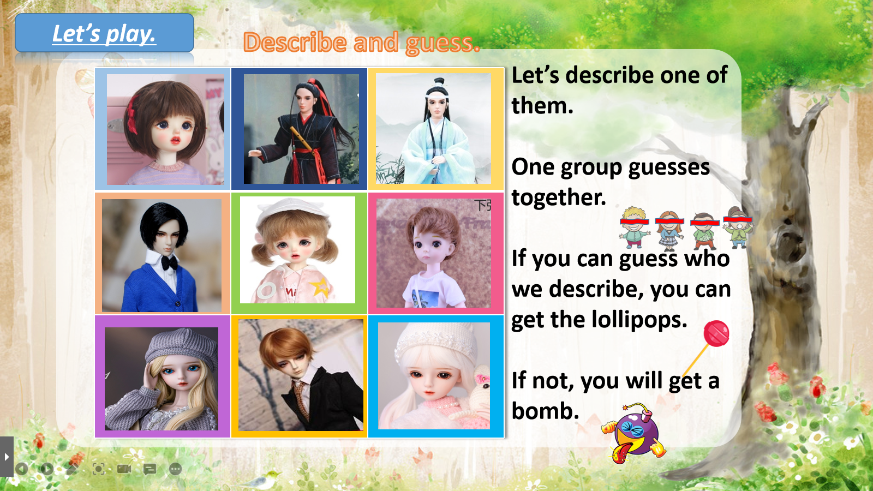
First, I describe a doll. You guess.
He is a man. His hair is short. He is in black.
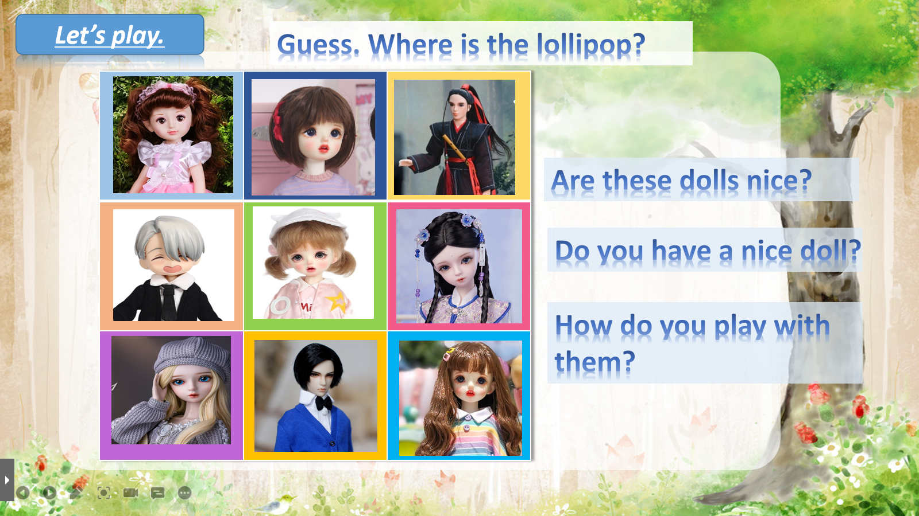
Now, it’s your turn. Please describe one of them.
One group guesses together.
If you can guess who we describe, you can get a lollipop.
If not, you will get a bomb.

Are these dolls nice?
Do you have a nice doll? Show us please.
How do you play with them?
Do you hug your doll? Do you play with...? Do you read books with...? Do dress up with ....?
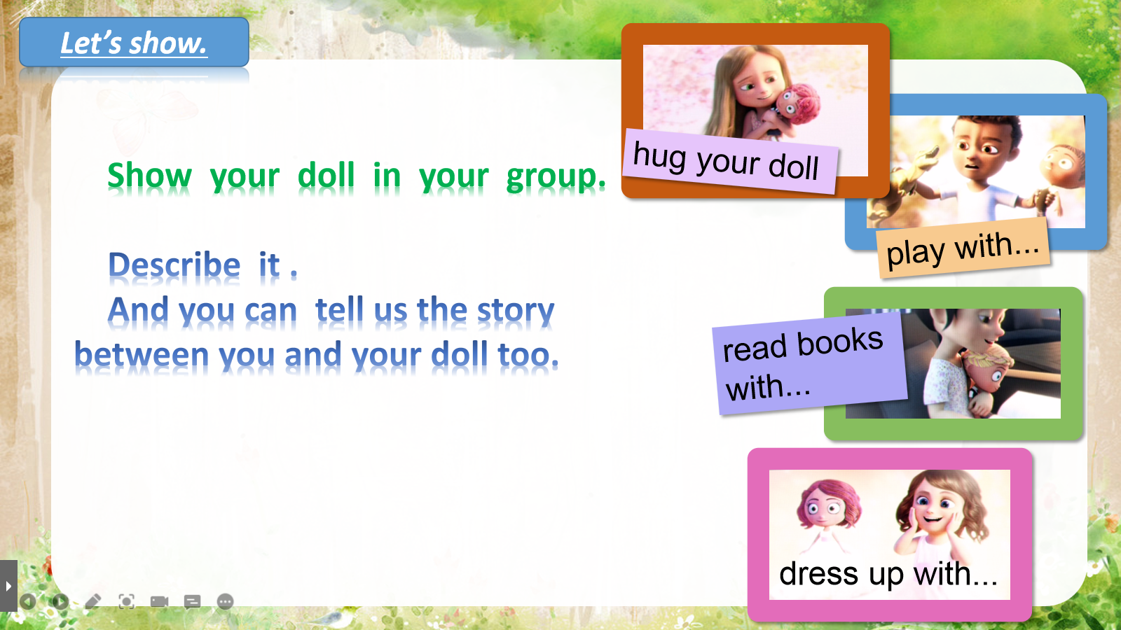
Step 5 Let’s show.
Now, show your doll in your group.
...
You can show your dolls like this.
Look, this is my doll.
(Describe the doll’s appearance.)
His/her face/hair/eyes/...
(Describe doll’s clothes.)
His/her dress/skirt/coat/...
(Tell us more about you and your doll)
I play/ read.../ dress up/ with my doll.
I hug my doll.
...
(At last ...)
He/She is beautiful/nice/smart/cool...
I love my doll.

Look, here’s a boy. He will show you his doll.
Now, it’s your turn. Please show your doll in your group first.
配乐介绍 拍视屏
Who can show your doll here.
Everybody, you like dolls. Can you tell me why? I love dolls, because ...

