四年级英语期中质量监测 2019.11
班级 姓名 得分 等第

听力部分 (共28分)
一、听录音，选出你所听到的内容，听两遍。(8分)
( ) 1. A. Mike B. like C. milk
( ) 2. A. don’t B. duck C. dog
( ) 3. A. cake B. cool C. cute
( ) 4. A. twin B. toy C. two
( ) 5. A. wonderful B. beautiful C. breakfast
( ) 6. A. eight B. either C. eighteen
( ) 7. A. have a lion B. have a look C. have a try
( ) 8. A. Do you like animals? B. Do you have any animals?
C. Would you like some animals?
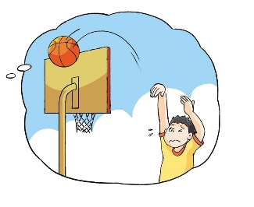
二、听录音，给下列图片标序号，听两遍。（6分）
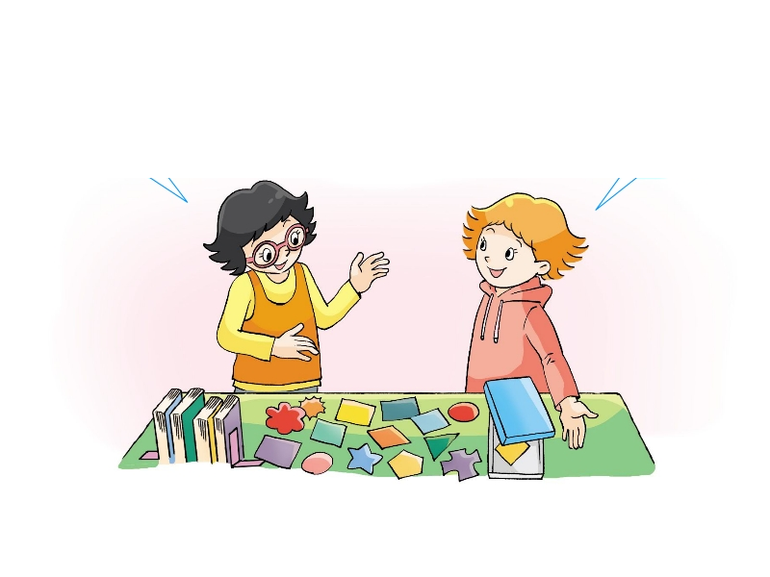
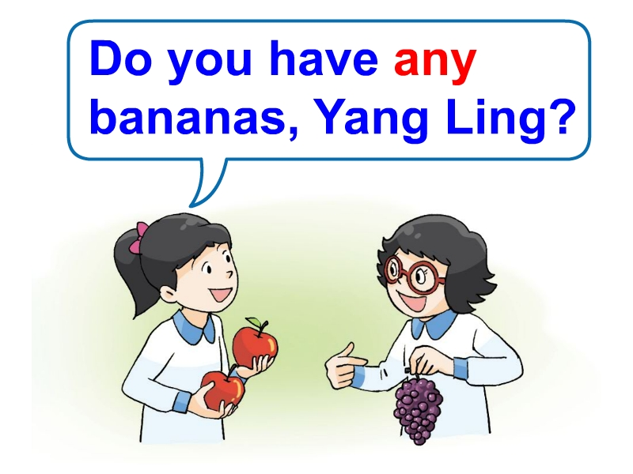
1. 2. 2. 3.

（ ） （ ） （ ）
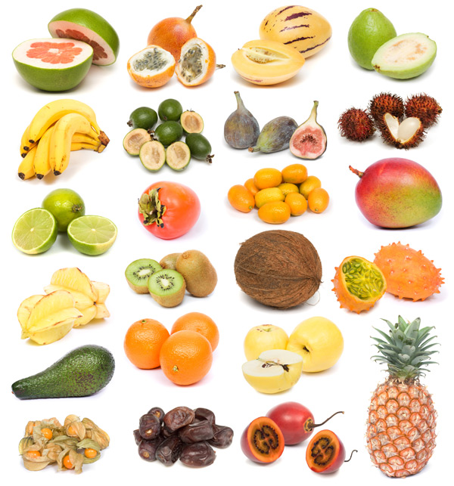
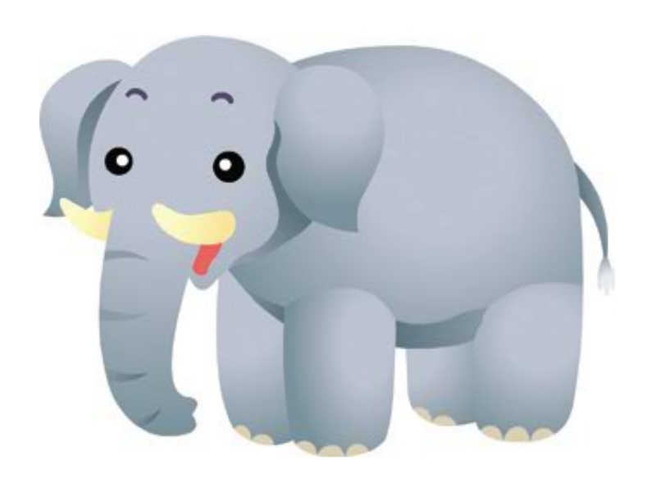
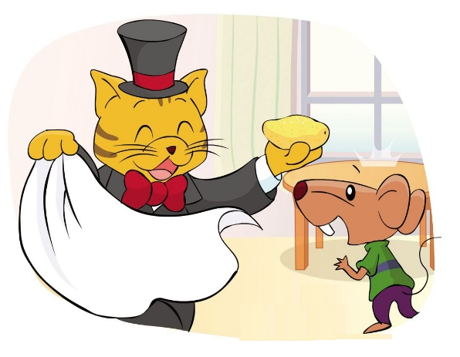
5. 6. . 4.

（ ） （ ） （ ）
三、听录音，根据所听问句，选择恰当的答句，听两遍。(6分)
( ) 1. A. No, I don’t . B. Yes, please. C. It’s cute.
( ) 2. A. This is a lion. B. It’s a peach. C. They’re tigers.
( ) 3. A. Yes, I do. B. I’d like mangoes. C. I have three.
( ) 4. A. Sure. Here you are. B. Yes, it is. C. How nice!
( ) 5.A. No, he can’t. B. Yes, she can. C. Yes, he can.
( ) 6.A. I can play football. B. Yes, I do. C. No, I can’t.
四、听录音，填入所缺单词，每空一词，听三遍。(8分)
1. _________ at__________ classroom. ________ beautiful.
2. I have __________ ___________.
3. How _________ ___________ do you have?I have __________.
笔试部分（共72分）
一、判断下列各组单词划线部分的读音是S否D相同. (4分)
( ) 1. have horse ( ) 2. cake nice
( )3. tiger good ( ) 4. robot cap
二、按要求写词。（8分）
1. can’t(完全形式) ____________ 2. those(单数)____________
3.boy (对应词) ____________ 4.let’s (完全形式)__________
5.some（同义词）__________ 6. good(副词)____________
7.box(复数) ____________ 8. either(同义词)__________
三、英汉互译。 (10分)
1. 18只猫________________ 6. cute and fat ______________
2. 不喜欢马 ___________ 7. in that box ____________
3. 许多足球_______________ 8 . play table tennis _____________
4. 打篮球 _________________ 9. have a try ____________
5.游泳游得好______________10. I can’t jump either.___________
四、找出每组中与其它两个不同类的选项。（每小题1分，计5分）
( ) 1. A. fly B. skate C. ball
( ) 2. A. salad B. cake C. book
( ) 3. A. cool B. that C. wonderful
( ) 4. A. they B. here C. there
( ) 5. A. nice B. yes C. beautiful
五、单项选择。 (13分)
( ) 1. I have a________. I like _________.
A. doll , doll B. dolls , doll C. doll , dolls
( ) 2. --__________ balls do you have? --Seven.
A. How old B. How many C. What about
( ) 3. They _________ cute and fat.
A. is B. are C. do
( ) 4. --Do you have ______ apple? -- No. I have ______ oranges.
A. an, B. an, some C. an, any
( ) 5. I have five .
A .mangos B. mango C. mangoes
( ) 6. --Can Mike play table tennis? -- Yes， ______.
A. I can B. he can’t C. he can
( ) 7. --Can you fly _________，little bird? -- Yes, I can.
A. well B. nice C.great
( ) 8. -- Ouch! I can’t skate. -- __________.
A. Have a try B. Cool C. Yes, I can
( ) 9. --What do you have? -- _________.
A. I have some balls B. I can play balls C. I like balls
( ) 10. Can you play _____?
- a football B .basketball C. the table tennis
( ) 11. ---What’s this? ----It’s ______ little elephant.
A. an B. a C. those
( ) 12. ---________ books do you have? ---I have four.
A. How many B. What about C. How much
( ) 13.---______ those apple trees? ----No,______ pear trees.
A. Are; they’re B. Are; it’s C. Are; They’re
五、左右搭配(8分)
( )1 Do you have any cakes? A.Yes, I do. They’re cute
( )2 How many balls do you have? B .How lovely!
( )3 Look at my toy animals. C .No, I don’t.
( )4 Can Helen swim? D.I have seventeen.
( )5 What do you have？ E .Yes, I can play well.
( )6 Do you like cats? F. It’s under the tree.
( )7 Can you play football? G .I have some grapes .
( )8 Where is my dog? H .Yes, she can.
六、连词成句。（注意大小写和标点符号）（10分）
1. swim can’t I either ( . )

- many have do how stickers you ( ? )

- play table you tennis can ( ? )

- skate she well can very( . )

- eighteen have crayons I ( . )

七、根据中文补全下列句子。(9分)
1. 你喜欢熊猫吗？ 是的，我喜欢。
Do you __________ __________ ? _________, I________.
2. 你有一些玩具狮子吗？ 不，我有一个玩具马。
Do you have _________ toy lions? No, I have a toy _______.
3. 他会踢足球吗？ 不，他不会。他会游泳。
________ he ________ _______? No, he can’t. He can _______.
4. 你有多少个贴纸? 我有2个。
How _________ _________do you have? __________.
5. 你会做水果沙拉吗？ 当然。
________ _________ _________ a fruit salad? __________
八、阅读理解。根据对话内容判断正（T）误（F）。 (5分)
A: Welcome to our school.B: Thank you.
A: Look, this is our classroom.
B: How nice! How many boys and girls are there in your class?
A: Nineteen boys and eighteen girls.
B: Oh, I see. Look, what’s behind the door?
A: Let me see. It’s a football. Do you like it?
B: Yes. I can play football very well.
A: Me, too. Let’s go and play football.B: Great!
( )1. They are in the school.
( )2. There are(有) nineteen boys in their (他们的) class.
( )3. The basketball is behind the door.
( )4. They can play football very well.
( )5. There are eighteen girls in their school.

