6B Unit7 Summer holiday plans
- Teaching Contents:
Revision
二、Teaching aims：
1 能正确、流利、生动地讲故事Summer holiday plans.
2 能正确并总结运用本课的将来时特殊疑问句的语法构成。
3 能谈论自己和他人的假期（旅行）计划及出行方式。
4能了解一些世界上的大的城市，包括名胜古迹，著名景观。
三、Focus of the lesson and predicted area of difficulty：
1 综合复习本单元的词句，熟练掌握。
2 在综合复习的基础上能正确谈论假期计划和出行方式并能完成相应的短文写作。
四、 Teaching aids：
和朋友或家人讨论想要去的地方，具体的地点和标准性建筑物，不会的可以查字典。
Step1.Lead in
Watch a video about some interesting countries.
Step2 Presentation
1.Go over the book
a.Ask Ss how to make travel plans
b.Ask Ss to go over the book by themselves, read the Unit 7 quickly and loudly think about one question : what are their plans?
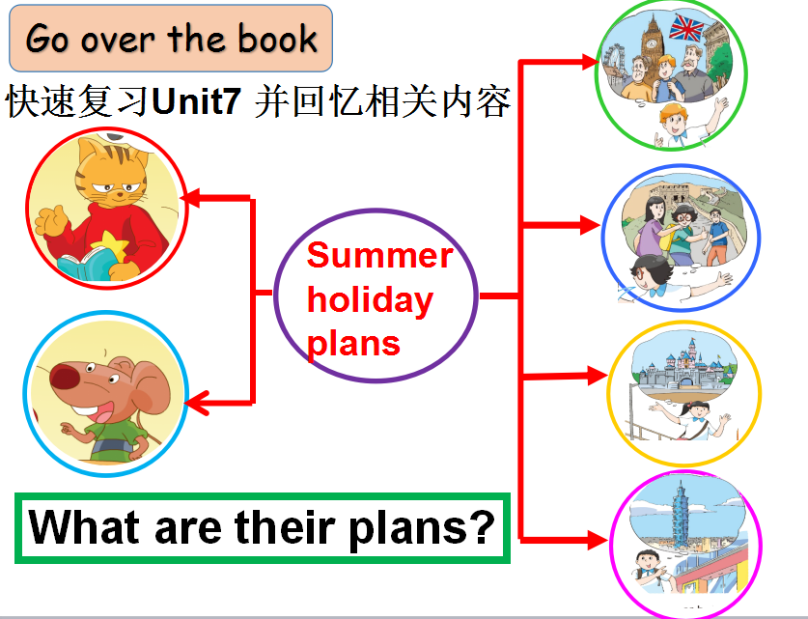
2.Let’s review
a.Make a mind map about Mike’s plans by teacher.
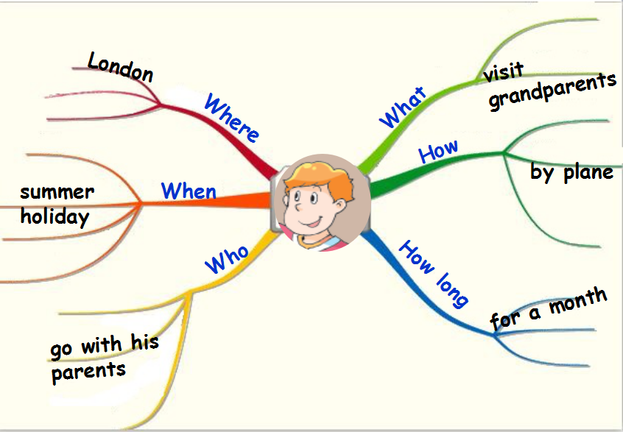
b.Group work :ask Ss to choose other’s to finish their mind map and have a report.
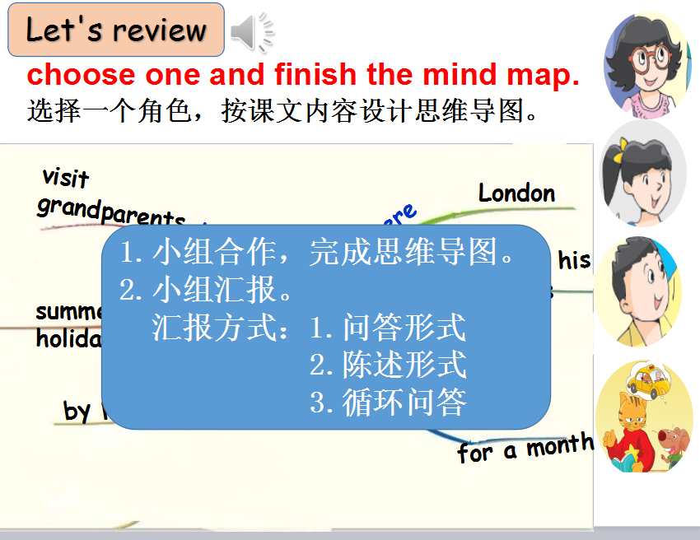
3.Let’s find
According to the story time and cartoon time ,ask Ss to answer several questions and according to the sentences, find the rule.
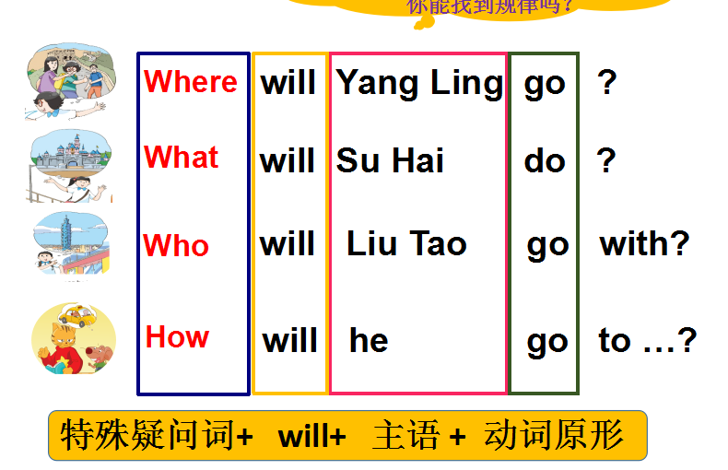
4. Let’s play
Show some pictures,let Ss answer: where will you find it ?Ss:We will find _____in______.
Rules:ring the bell,stand up quickly,after each round pass the bell
Step3 Consolidation
1. Let’s read
a.Introduce a new friend Millie ,she likes travelling ,so this summer she will go to Hawaii,now she tells her plans.ask Ss to read the plans quickly,and underline the answer:what will she do ?
b.Finish Millie’s mind map.
c.According to the Millie’s mind map,let’s try to retell her plans.
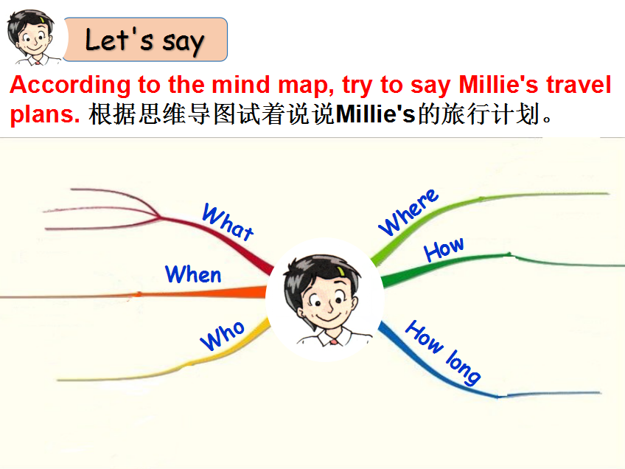
2. Let’s talk
If you have a graduation travel ,Where will you go?/What will you do?/How will you go there?/How long will you stay there? …
Step4 Production
Let’s write.Ask Ss to write their travel plans
Step5.homework
1.Know more interesting countries
2.Talk about their plans with family.
3.Read one book about “travelling”

