Unit 4 Where’s the bird?
班级 姓名___________
课内巩固
一、英汉互译
1在椅子下面 2 在桌子上面
3 in the tree 4 under the schoolbag
5 in the pencil case 6 It’s not here.
7 我的钢笔在哪里？ 8 He’s behind the door.
二、根据图片填入合适的单词，补全对话。
1 | 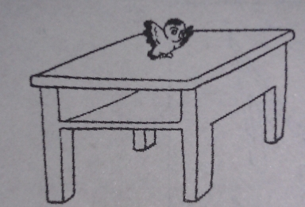 | 2 | 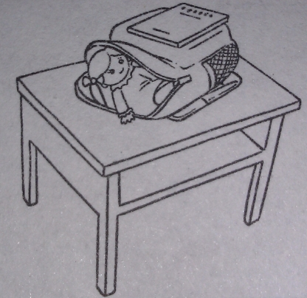
A: Where’s the ?  B: It’s the . |  | A: Is the doll in the schoolbag?  B: , it .
3 | 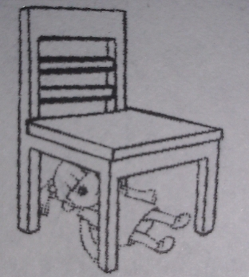 | 4 | 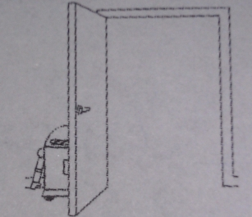
A: Is the doll on the chair?  B: , it . |  | A: Where’s the robot?  B: It’s the .
三、从方框中选出适当的句子，补全对话。
( ) 1 A: Look at the bird!
A I’m sorry.

B How beautiful!

C Yes, it is.

D Where’s my rubber?

E Is it under the book?
B:
( ) 2 A:
B: It’s under the book.
( ) 3 A: Is that your ruler?
B:
( ) 4 A:
B: No, it isn’t.
( ) 5 A: Don’t run in the library.
B:
四、根据上下文补全对话
A: my pencil? I can’t find(找不到) it.
B: this your pencil?
A: No, it . My is red.
B: Look! It’s behind your lunch box.
五、读句子，仔细体会画线部分的读音，想想我们还学过哪些含有字母d的单词，写写看。
The red doll and the hot dog are good too.

六、从Ⅱ栏选出栏Ⅰ相匹配的答句。
Ⅰ | Ⅱ
( ) 1 Where’s the parrot? | A Thank you.
( ) 2 Is this my lunch box? | B It’s a lunch box.
( ) 3 What is it? | C No, it isn’t.
( ) 4 Look at my skirt? | D It’s nice.
( ) 5 This chair is for you. | E It’s under the desk.
课后拓展
根据对话内容判断句子正误，正确写T，错误写F。
Yang Ling: Happy New Year, Helen!
Helen: Happy New Year, Yang Ling. ( ) 1 It’s the new year.
Yang Ling: This is for you, Helen. ( ) 2 The ball is in the box.
Helen: Thank you. What’s in the box? ( ) 3 The doll is for Helen.
Yang Ling: Guess. ( ) 4 The ball is for Yang Ling.
Helen: Is it a ball?
Yang Ling: No, it isn’t.
Helen: Is it a doll?
Yang Ling: Yes, it is. This doll is for you.
Helen: Thank you.

