三年级下册调研卷
生态科技岛小学
听力部分30分
一、听录音,选出你没听到的内容 (6)
( )1. A. big B. Bob C. ball D. books
( )2. A. new B. Nick C. Nancy D. nine
( )3. A. farm B. Welcome! Ｃ.Tom D mum
( )4. A. two B. eight. C. ten D. time
( )5. A. eat. B. drink. C. talk D. Don’t
( )6. A. in B. under C. behind D. bird
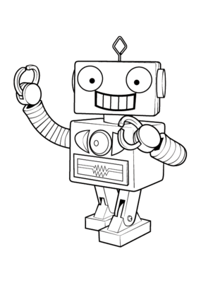
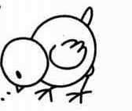
二、听录音,判断所听内容是否与图片相符,相符的写Ｔ,不相符的写Ｆ (6)
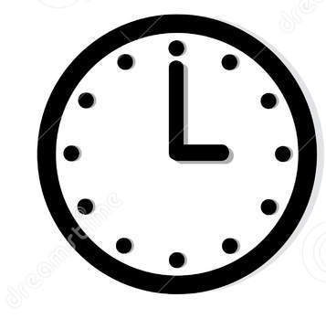

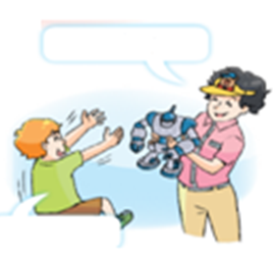

( ) ( ) ( )
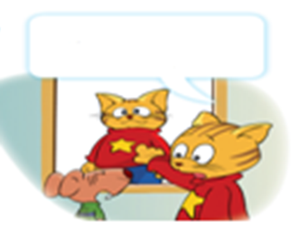

( ) ( ) ( )
三、听录音,选择合适的答句(6)
( )1 A He’s my brother. B She’s my sister.
( )2 A No. They’re apples. B Yes. They’re apples.
( )3 A I’m nine. B It’s nine.
( )4 A Thank you. B You are out.
( )5 A This isn’t my pencil. B. No, it isn’t
( )6 A. Yes, it is. B It’s over there.
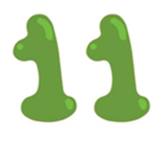
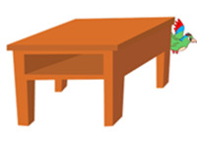
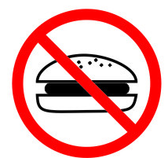
四、根据所听内容，给以下图片排序(2*6=12)


( ) ( ) ( )
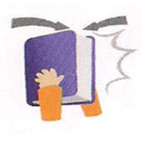
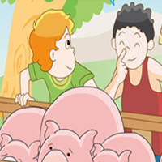

( ) ( ) ( )
笔试部分70分
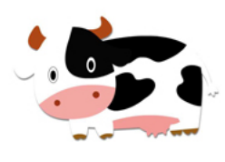
一、根据图片提示完成句子。2*8-16
1 A: What colour is this ________?
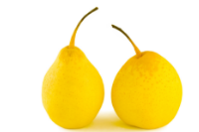
B: It's black and white.
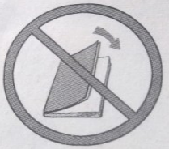
2 A: What are these?
B: They're _______
3 Don't ______ the _______.
4 A: What ______ is it, please?
B: It's _______ o'clock, Jack. It's time ______ _________.
A: OK.
二、找出不同类的单词。（12）
( ) 1. A. blue B. ball C. black
( ) 2. A. pie B. stand C. sit
( ) 3. A. crayon B. ruler C. me
( ) 4. A. ball B. book C. look
( ) 5. A. eat B. drink C. sweet
( ) 6. A. sleep B. in C. talk
( ) 7. A. pencil case B. shout C. open
( ）8.A.desk B. nice C. beautiful
( ）9.A.ten B. pencil C. pen
( ）10. A. you B.I C. meet
( ）11.A.on B. under C. this
( ）12.A.here B. there C. where
三、选用适当的单词填空，补全句子6
1.oranges 2.eat 3.woman 4.under 5.shout 6.rubber
That _____ is my aunt.
Don't ______ in the library.
Is this a _______, Mike?
It's time to _______ now.
Your bag is ______ the bed.
Those _______ are very nice.
四、选出最佳选项10
（ ）1—_____ be late. —OK.
A. Not B. Don't C. You
（ ）2 —Who's that woman? —_____ my aunt.
A. He's B. She's C. It's
（ ）3 _____, Tom. It's eight o'clock. It's time for class.
A. Hurry up B. Sorry C. Good night
（ ）4 —_____? —Yes, it is.
A. What's this? B. Where's my pencil? C. Is my pencil under the desk?
（ ）5 —_____ are you? —I'm three.
A. How old B. How C. Where
（ ）6 —What colour is the T-shirt? —_____.
A. It's yellow B. It's a T-shirt C. It's a yellow skirt
（ ）7 —Guess. What's that? —A rubber? —Sorry, _____.
A .you're right B. you're out C. that's OK
（ ）8 —I'm Lily. She's Lucy. _____ twins. —Nice to meet you.
A. They're B. We're C. You're
（ ）9 —Mike, please close the windows. —_____.
A. Sorry B. Yes, please C. Yes, Miss Li
（ ）10 —Is that your grandpa? —_____.
A. Yes, she is. B. Yes, he is. C. Yes, it is.
五、根据情景选择合适的答句16
（ ）Are these cakes? a. Nice to meet you, Helen.
（ ）Who's she? b. Thank you.
（ ）What are those? c. They are birds.
（ ）It's time for bed. d. Yes, he is.
（ ）Is that man your uncle? e. It's behind the door.
（ ）Welcome to my farm. f. OK, Dad.
（ ）Where's the toy car? g. She's my aunt.
（ ）This is Tom's cousin, Helen. h. No, they're pies.
六、将下列句子排列成完整的对话5
（ ） Is this your father?
（ 2 ） Oh, it's nice.
（ ） No, he isn't.
（ ） Look, this is my picture.
（ ） Who's your father?
（ ） This is my father.
七、阅读下列对话，根据对话内容判断正误，正确的打√，错误的打×5
It is ten o'clock in the morning. Kate and Lucy are on the farm.
Kate: Good morning, Lucy.
Lucy: Good morning, Kate. Welcome to my grandpa's farm.
Kate: Thank you.
Lucy: Come and see some animals with me.
Kate: What are these?
Lucy: They are cows.
Kate: What are those?
Lucy: They are pigs.
Kate: Wow, they are very fat.
Lucy: Yes, they are very lovely. I like them very much. Lily likes them ,too.
Kate: Who is Lily?
Lucy: She is my sister.
Kate: How old is she?
Lucy: She is ten.
Kate: Ten? Are you ten, too?
Lucy: Yes, we are twins. Look, she is over there. Let's go to say "Hello" to her.
Kate: OK.
(1) Kate, Lucy and Lily are on the farm. （ ）
(2) The farm is Kate's grandpa's. （ ）
(3) The cows are very fat. （ ）
(4) Lily and Kate like pigs very much. （ ）
(5) Lucy and Lily are twins. （ ）
听力
一听录音,选出你没听到的内容 (6)
1Big books, big books, Bob has two big,big books.
2 Nick is nine, Nancy is ten. Nick has a book. Nancy has a pen.
3 Clever Tom from the farm, makes ice cream for his mum
4 Tick-tock. Eight o’clock. It’s time to eat. Tick-tock. Ten o’clock. It’s time to meet.
5 Don’t eat or drink in the metro. I’m sorry.
6 Where’s the bird? It’s under your desk. Now it's behind the door.
二听录音,判断所听内容是否与图片相符,相符的写“Ｔ”,不相符的写“Ｆ”, (6)
1 What’s this? It’s a rubber.
2 Is this a duck? No. It’s a chicken.
3 What time is it? It’s six o’clock. It’s time for dinner.
4 This ball is for you. Thank you.
5 Paul is walking up and down.
6. This is not John. This is me. My name is Sam.
三、听录音,选择合适的答句(6)
1 Who’s that girl?
2 Are those oranges?
3 How old are you?
4 Happy birthday!
5 Is this your pencil?
6 Where’s my book?
四、根据所听内容，给以下图片排序(2*6=12)
1 It’s twelve o’clock. It’s time for lunch.
2 Where’s the bird? It’s behind the desk.
3 Don’t eat in the library. I’m sorry.
4 What are these? They’re pigs.
5 How old are you? I’m eleven.
6 Close your book, please. OK.

