Unit 6 At the snack bar
课堂作业：
一、听录音，勾选出麦克一家选择的食物和饮品。
 |  | 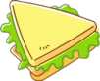 | 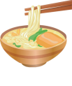 | 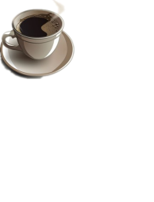 | 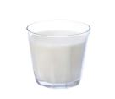
Mike
Helen
Dad

- 判断哪些是营业员说的话，哪些是顾客说的话。将选项填在对应的方框里。
Waitress/waiter(服务员)
Customer(顾客)
A: I’d like a/some... | B: Anything else?
A: ... please. | B: Here you are.
A: What do you want? | B:I want...
A: What else do you want? | B: What would you like?
课后作业：
- 根据首字母提示补全句子。
- People in China like to drink t__________.
People in USA like to drink c__________.
- My little brother would like to eat a h________ in the KFC.
- We often eat chips(薯条) at the s_____ b_____.
- 理解与运用
一杯牛奶_________ 一杯茶_________ 一杯咖啡________

