**小学英语六年级上册阶段练习卷** 2020.11

学校 班级 姓名 学号

成绩

**听力部分（20%）**

1. **听录音，选出你听到的内容，将序号填入括号内。（6分）**

(    ) 1. a. little b. letter c. litter d. let

(      ) 2. a. could b. cloudy c. cloud d. clothes

(      ) 3. a. were b. wear c. where d. word

( ) 4. a. things b. though c. throw d. through

( ) 5. a. find b. found c. friend d. front

( ) 6. a. flew away b. moved away c. went well d. another day

1. **根据所听内容，判断其与图意是否相符，正确的写T，错误的写F。(6分）**
2. 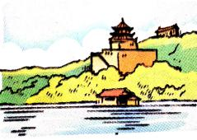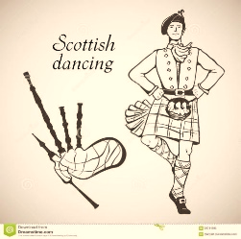 2. 3.

( ） （ ） （ ）

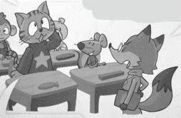4. 5. 6.

（ ） （ ） ( )

**三、听录音，根据所听对话及问题，选择正确的答案。（5分）**

( )1.a. Tall and thin. b. A blue shirt. c. He’s Mr Green.

( )2.a. They are watching a film. b. They are having a lesson at school.

c. They are having a picnic in the park.

( )3. a. She flew the kite happily. b. She bought a kite.

c. She lost her kite.

( )4. a. Yes, he was. b. No, he didn’t. c. No, he wasn’t.

( )5. a. A photo. b. A story. c. A cartoon.

**四、听录音，根据所听内容，补全对话，每空一词。（3分）**

A: Hi, Lily. Where did you go for the Day holiday?

B: My family and I went to and had a nice trip.

A: Great! What did you do there?

B: At , we went to the Bund.

On the second day, we the Natural History . We saw many interesting things there. I was so .

A: Wow！What great fun!

**笔试部分（80%）**

1. **语音：选择合适的词完成句子，使得小诗的意思通顺并且押韵, 填序号。(4分)**

1. *friends b. see c. Year d. dear*

*e. hear f. dinner g. week h. cheer*

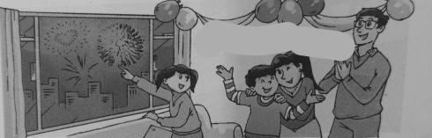Daddy said, “Come here, my ”.

Listen, listen, can you ?

It’s the song of the New .

Let’s have a party to have a .

**二、词汇：**

**A. 根据中文或首字母提示完成句子，并注意单词的适当形式。（5分）**

1. The students are playing table tennis. Sam and Bobby (开始) first.

2. The little boy l at the king, because the king didn’t wear any clothes.

3. Many years ago, people could only b things from shops.

4. Look! The weather b sunny now. Let’s go climbing, Tom.

5. When I was a little c , my mother usually t me stories before bedtime.

6. Y was Thursday. Today is Friday.

7. --You look worried, Jane. What h ?

-- My cousin put my book in the water. It is wet now.

1. Do your parents read n now? --No, they get news on the I .

**B.选择合适的内容填空，填序号。（8分）**

*a. magic stick b. Each worker c. hold onto d. their turn*

*e. Yu Gong and his family f. the compass g. on holiday h. waited for*

1. The fairy had a . It helped Cinderella go to the party with a pretty dress.

2. works hard to move the rocks away.

3. Jack, please give the ball to the twins. It’s .

4. Miss Fox asked a question, then she the students’ answers.

5. were tire but happy.

6. My family and I took the plane to Hainan Island last Saturday. Now we are .

7. The Chinese have four great inventions, like paper making and .

8. It was so windy this afternoon. I had to my hat all the way home.

**C. 给下列短语选择正确的英文释义，将序号填入括号内。(6分)**

（ ）1. a fashion show

a. People usually wear pretty and fashionable clothes in it.

b. We can watch funny cartoons in it.

（ ）2. a holiday album

a. There are some interesting stories in it.

b. We can see some nice photos in it.

（ ）3. Palace Museum

a. It was the king’s home in the Ming and Qing Dynasty(朝代).

b. It was a big beautiful park for the kings and their families.

（ ）4. half past six

a. It is six thirty. b. It is five sixteen.

（ ）5. grandchildren

a. They are my father’s parents. b. They are my children’s daughters or sons.

（ ）6. an e-book

a. We read it to get news many years ago.

b. It is a new kind of book with no paper.

**D. 读句子，选择单词的正确形式填空，并抄写在横线上。（7分）**

1. At the fancy dress party, Tina (wear) beautiful clothes and had a good time. w 2. Patrick is my e-friend. I usually write emails to (he) .

3. --Where (be) you last night? – I was at home.

4. --Did Liu Tao________ (catch) any fish on the farm? –No, he didn’t.

5. Now people can use the computer (do) many things. It’s convenient（方便）.

6. My cousin (write) me a letter and talked about his exciting trip in London.

7. --Sam, (make) a sentence with the word “egg”. –Yes, Miss Li.

**三、单项选择。（10分）**

( ) 1. I called you last week，but you at home.

a. were b. wasn’t c. weren’t d. didn’t

( ) 2. The jeans fit the cowboy well. They are for him.

1. too long b. too short c. just right d. so big

( )3. – it rain last Monday? –Yes, it heavily.

1. Did; rainy b. Did; rained c. Was; rained d. Was; rainy

( ) 4. -- did you do last weekend?

–I the Nanjing Museum with my brother.

a. What; went b. Where; went c. Where; visited d. What; visited

( ) 5. My cousin likes reading stories. He read picture books .

1. now b. when he was little c. tomorrow d. next week

( ) 6. --Does your mother often presents on her birthdays?

--Not very often, but she a pretty dress from my father this year.

a. gets; gets b. get; got c. make; made d. buy; bought

( ) 7. --Mr Green, I can . S-e-n-t-e-n-c-e! --Well done, Jim!

a. make the sentence b. spell the word c. sing the song d. tell the story

( ) 8. Don’t do that thing. It’s dangerous(危险) for us.

a. foolish b. clever c. interesting d. exciting

( ) 9. There were black clouds in the sky. The weather became soon.

1. sunny b. fine c. good d. rainy

( )10. My mother with her friends on the telephone many years ago, but now

she can with them online anywhere.

1. chatted; chat b. chats; chats c. chat; chats d. chatted; chatting

**四、语言交际：**

**A. 从Ⅱ栏句子中选出与Ⅰ栏相对应的答句。（共7分）**

**Ⅰ Ⅱ**

( ) 1. When did the twins make the snowman? a. They did some housework.

( ) 2. Can you answer my question, Sam? b. Yes, it was a fine day.

( ) 3. How did you get there? c. They made it last winter holiday.

( ) 4. Who’s wearing brown today? d. I took the train there.

( ) 5. What did your parents do just now? e. Yes, Miss Fox.

( ) 6. Was the weather sunny this morning? f. No, he couldn’t.

( ) 7. Could your grandfather write emails? g. Su Yang is.

**B．根据上下文情境，选择合适的句子完成对话，填序号。(6分)**

a. What did you do last Sunday? b. I wore a crown and dressed like a king.

c. Oh, what a day! d. So I went to school by bike

e. Of course, we did. f. We didn’t have any lessons that day.

A: Hi, Mike.

B: I went to the park with my parents by car.

A: That’s wonderful. Did you have a picnic there?

B: We really enjoyed our picnic time.

A: What about you, Liu Tao?

C: I went to a fancy-dress party.

A: It sounds great! Did you go to the party too, Nancy?

D: No, I got up at seven thirty. I thought it was late. Then I found it was Sunday.

A:

C: Ha! Ha! You missed the interesting party games.

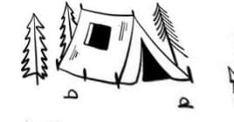**C、结合图意完成对话，每空一词。（6分）**

A: Where you go last weekend, Kate?

B: I went to a camping site with my .

A: it fun?

B: Yes, we did many things there.

A: Did you catch any fish?

B: No, but we some fireflies(萤火虫) and put them into a .

A: Wow! What a great trip!

**四、阅读：**

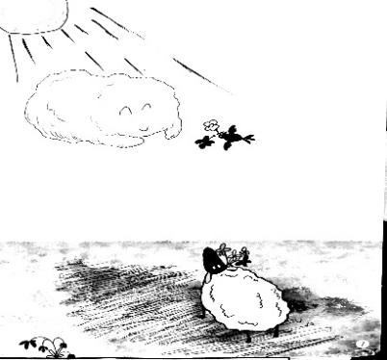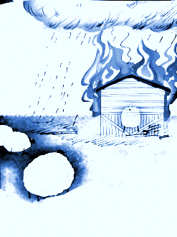**A. 阅读下面的故事，给图片配上合适的句子描述，填序号。（5分）**

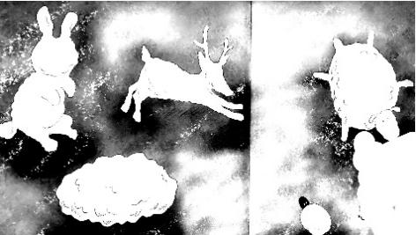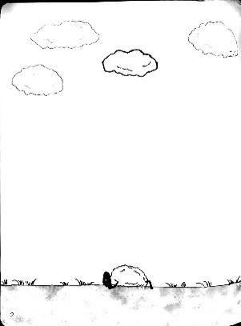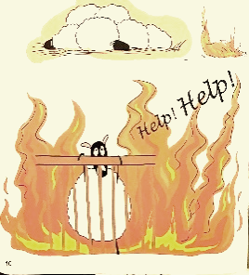

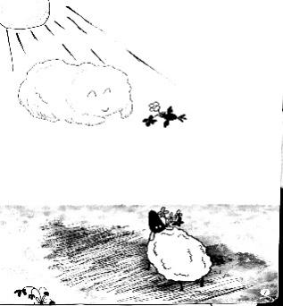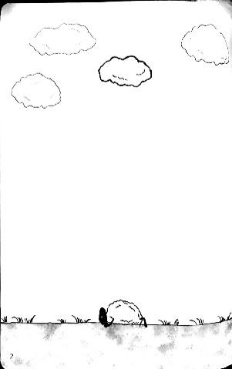

（ ） （ ） （ ） （ ） （ ）

***a.*** It was a nice spring day. The wind was gentle. Little Sheep Carl lay on the grass.

He 1 a beautiful white cloud in the sky.

***b.*** The cloud was funny. Sometimes it turned into a rabbit. Sometimes it was a sheep... “You can play 2 ! I’m Carl. Let’s make friends. OK?” “Of course. I’m Amy.”

***c.*** From then on, they played together. Amy kept the sunlight away from Carl. Carl asked birds 3 flowers to Amy.

***d.*** Happy times flew. On a dry autumn afternoon, all the sheep were sleeping. Suddenly, the farm caught fire. Carl 4 get out.

***e.*** Just then, a white cloud ran over and became darker and darker. Soon 5 dropped and put out the fire. Carl was saved.

**B.阅读以上故事, 选择正确的词填空。（5分）**

（ ）1. a. sees b. find c. found d. looked

（ ）2. a. magic b. cards c. football d. jokes

（ ）3. a. to make b. to write c. to give d. to buy

（ ）4. a. can b. can’t c. could d. couldn’t

（ ）5. a. wind b. sun c. rain d. clouds

**C.阅读短文，判断正误。（5分）**

My hometown Hongcun is an old but beautiful town. Many old people like living there, because it was a quiet place(地方). There were green mountains, fresh air and many old houses. However, it has changed(变化) a lot over the last ten years. Now there are many new squares, new streets and roads. You will find many tall buildings too. In the past, village people could only go to Hongcun by bike or on foot. Now they can take the taxi, the car, the bus or the metro to Hongcun. It is fast and easy to get there. The environment(环境) has also changed too. The water is cleaner, the mountains are greener and the air is fresher. People are happy to live in this beautiful town.

( ) 1. Hongcun is a quiet place for old people to live.

( ) 2. There were many old houses in Hongcun ten years ago.

( ) 3. There are a lot of tall buildings in Hongcun now.

( ) 4. People could go to the town by metro ten years ago.

( ) 5. The town is more(更……) beautiful now.

**五、写作：根据下列表格信息，写写Sally一家人七年来的变化。（6分）**

要求：1. 注意使用正确的时态。 2.不少于6句话。 3. 内容符合表格信息。

|  |  |  |  |
| --- | --- | --- | --- |
|  | ***Sally*** | ***Father*** | ***Mother*** |
| ***seven years***  ***ago*** | *read picture books* | *use the telephone* | *make friends at school* |
| ***now*** | *do many things* | *call people with a mobile phone* | *have many e-friends* |

**听力材料**

**一、听录音，选出你听到的内容，将序号填入括号内，听两遍。**

1.I want to write a letter to my friend.

2.Can you see the cloud in the sky? It looks like a sheep.

3.You were one-year-old in this picture.

4.Just now, the dog ran through the forest quickly.

5.Finally, Bobby found his new kite near the hill.

6.The weather was sunny today. The kite show went well.

**二、根据所听内容，判断其与图意是否相符，正确的写T，错误的写F，听两遍。**

1.– What’s the weather like today? --It’s windy. It’s good to fly kites.

2. Look at the picture. A Scottish man is wearing a kilt.

3.I visited the Palace Museum last summer holiday.

4.Miss Fox got angry about Sam and Bobby. Because they talked in class.

5.Nowadays, people can use the mobile phones to call people anywhere.

6.Easter holiday is a main school holiday in the UK.

**三、听录音，根据所听对话及问题，选择正确的答案，听两遍。**

1. A: Who’s that man in the blue shirt?

B: He’s our English teacher Mr Green.

A: Oh, I see. He is thin and tall.

Q: What is the man wearing?

1. A: Look, Tina. I brought some bread and honey. What did you bring?

B: See? I brought some fruit salad and some drinks.

A: Great! Let’s enjoy our lunch now.

Q: What are the children doing?

1. A: What’s the matter, Jane?

B: It’s windy. I can’t hold onto my kite. Finally, it flew away.

Q: What happened to Jane?

4. A: Hello, this is Mike speaking. May I speak to Wang Bing?

B: Sorry, he isn’t at home now. He went to the cinema twenty minutes ago.

A: OK. Thank you. I’ll call him this evening.

Q: Was Wang Bing at home twenty minutes ago?

5. A: Who’s this, Tim?

B: It was me five years ago.

A: Wow! You were lovely then.

Q: What are they talking about?

**四、听录音，根据所听内容，补全对话，每空一词，听两遍。**

A: Hi, Lily. Where did you go for the National Day holiday?

B: My family and I went to Shanghai and had a nice trip.

A: Great! What did you do there?

B: At first, we went to the Bund. On the second day, we visited the Natural History Museum. We saw many interesting things there. I was so excited.

A: Wow！What great fun!