Unit 7 Protect the Earth (Period 1)
一、Teaching contents教学内容
六年级上Unit7 Protect the Earth Story time
二、Teaching aims and learning objectives教学目标：
1、能理解、会说并朗读Story time。
2、能听懂、会说、会读和会写单词use,much,oil,drive,other和glass等。
3、 能听懂、会说、会读和会写句型We drink water and use water to clean things every day. We should ... We should not...
4、能够表达怎样保护地球，制作保护地球的英语海报。

三、Focus of the lesson and predicted area of difficulty教学重难点：
1、能理解、会说并朗读Story time。
2、能听懂、会说、会读和会拼写词汇use,much,oil,drive,other和glass等。
3、 能听懂、会说、会读和会写句型We drink water and use water to clean things every day. We should ... We should not...
四、Preparation教学准备：
PPT, books, teaching plans

五、教学过程：
Step 1. Warm up
- Greetings
2 Read and guess 游戏：根据句子提示，猜出相应的单词。
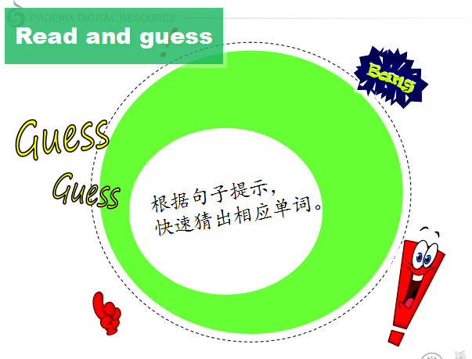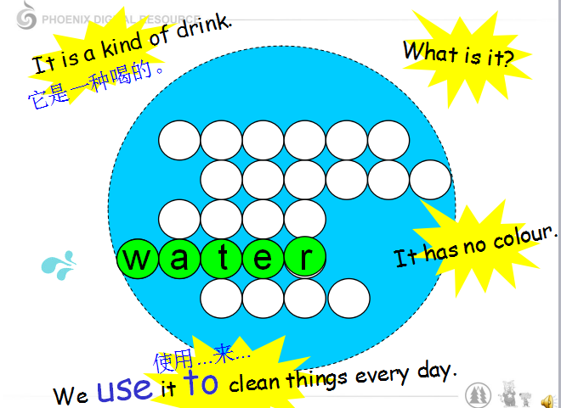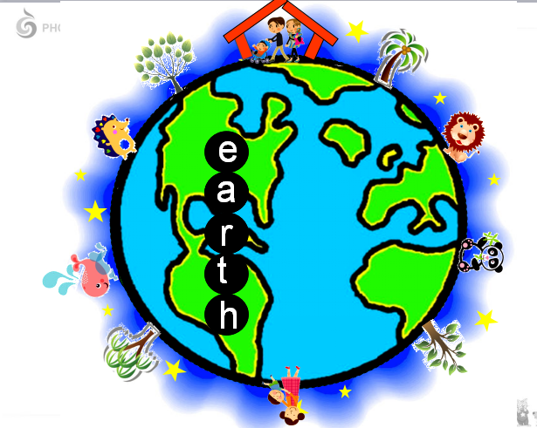
- 新授单词及词组useful, use...to, in many places和keep the air clean
- 通过字谜游戏导出生词earth和本课主题Protect the earth

Step 2 .Presentation
T: How can we protect the Earth? Now let’s watch a video. What problems are mentioned in the story?（仔细观看回答问题）
S1: The problem is water. S2: Trees are the problems.
S3: We should save energy. S4: And plastic.
T: You did a good job, boys and girls.Now let’s listen to the tape again and tell the names of each story. Did you get it? Let’s check.（出示板书）

T: Well done, boys and girls, now let’s try to fill in the blanks.
Energy comes from_____and____(PPT 教授单词 oil and coal)
______ comes from the trees.（PPT教授单词wood）
Part1 Save water
1）T: Now let’s read and judge.
S1: Water is useful，so we should not waste it. ( T )
S2: We use water to clean the things every day. ( T )
S3: There is much water in many places. ( F )
S4: We should not reuse the water. ( F )
2）T: Now we know water is useful, boys and girls, but why should we protect it and how? Please read and learn.
用直线画出原因 (Why do we save water?)
虚线画出方法 (How do we save water?)
S1: Water is useful. In many places, there is not much water.
S2: We should reuse and save it.
3）T: Wonderful, boys and girls. Now let’s listen to the tape and read after it.
Part2.Save energy
1)T: We know water is useful. What about energy? Please read and choose.
1 Most of the energy comes from___B___.
A. water and soil. B. coal and oil.
2. We should _____A______ and we should not_______________.
A. save energy; drive so much B.drive so much; save energy

2)T: Now let’s find out why should we save energy and how to save it.
用直线画出原因 (Why do we save energy?)
虚线画出方法 (How do we save energy?)
S1: Because there is not much coal and oil on earth.
S2: We should not drive so much because cars use a lot of energy.
3)T: So I think we can ride bikes,take the bus or metro to school. Now let’s listen to the tape and read after it.
Part3. Save trees
T: Now we know water and energy are important, what else are important too?
S: They’re trees.
1)T:Please read Part3 and answer the questions.
Where does wood come from?
Why should we not cut too many trees?
2)Perfect ! Now let’s try to fill in the blanks, boys and girls.
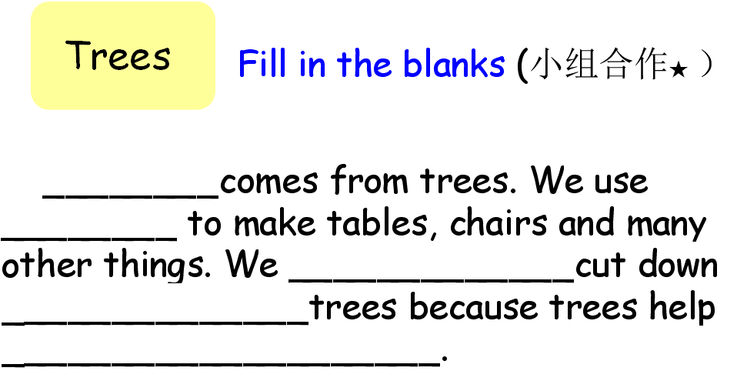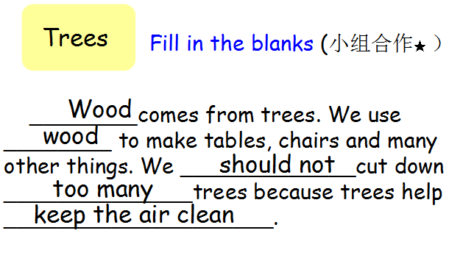
Part4. Don’t use too much plastic
T: Wood comes from trees, do the plastic come from the trees?
S: ....
T: So what do you know about plastic? You can have a group discussion.
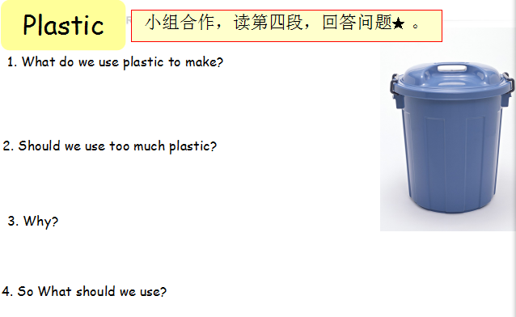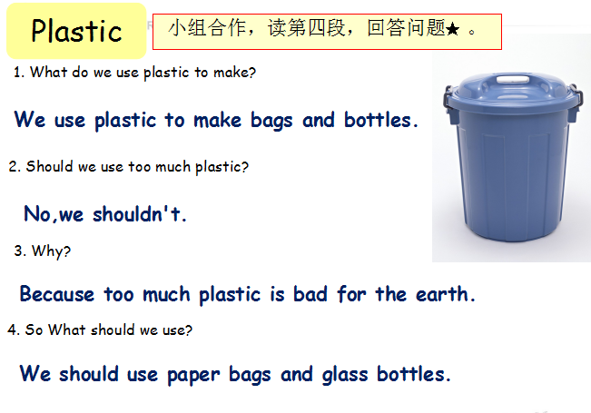
T: OK, it’s time for reading.You can read by yourselves or get into a group.

Step 3. Consolidation.
1 Reading time.
2.Speech time .(小组合作,每组选择文中的一个小主题, 讲解一个环保小知识）
Why do we …?
How can we save...?
Where do most of our energy come from?...
3.切合主题，提出保护口号.
T: We should protect the Earth because she give us too much.
Save the world,save our lives. 拯救地球，拯救我们自己。
Save energy,save our planet. 节约能源，拯救地球。
Think green. 树立绿色意识。

Homework
- 熟读课文并背诵。
- 小组合作制作一份保护地球的英语海报，要求人人参与汇报。.

Blackboard design板书设计：
Unit7 Protect the Earth Nov.29th
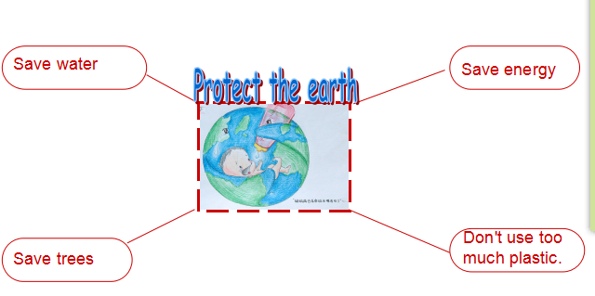

六、教学后记

