**Unit 6 Colour**

**课内基础：**

**1. Listen and circle（听录音，圈出正确图片）**

**Q：What does Yang Ling use to make a magic show?**

**（杨玲用什么道具表演魔术的？）**

**C.**

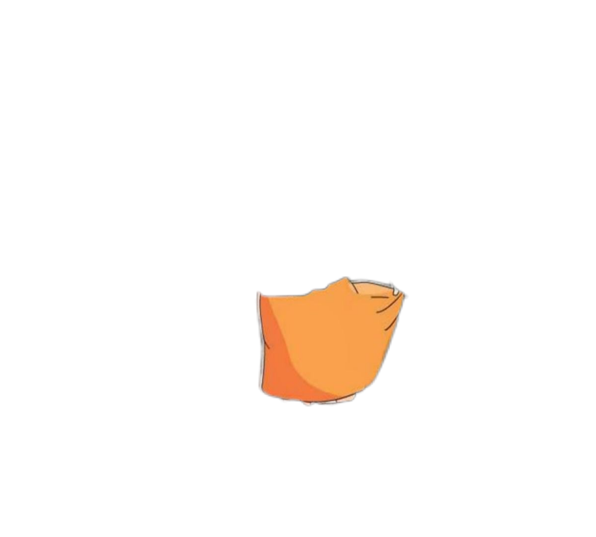

1. 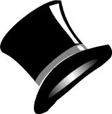

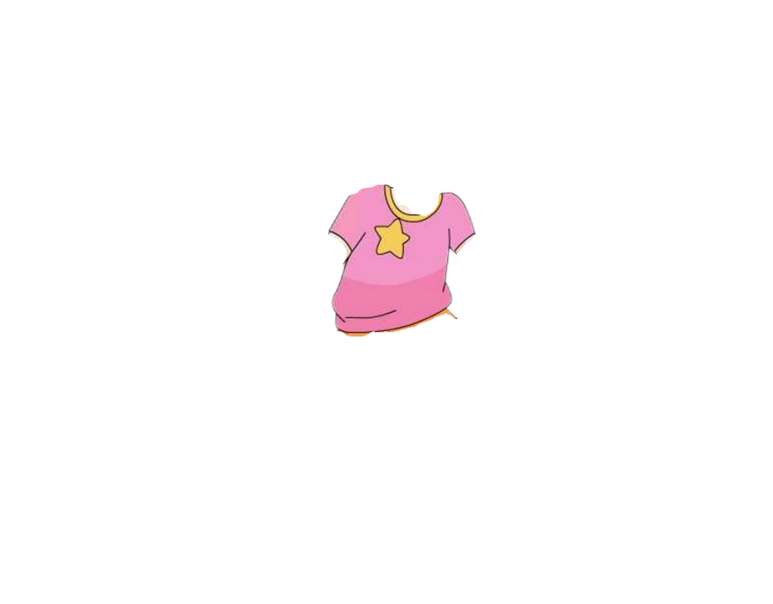

**B.**

1. **Watch and tick (看卡通，打✔）**

**Q：What colour is Yang Ling’s skirt ? (杨玲的短裙是什么颜色的？）**

|  |  |  |  |  |
| --- | --- | --- | --- | --- |
|  | red | blue | green | orange |
| 1 |  |  |  |  |
| 2 |  |  |  |  |
| 3 |  |  |  |  |

**课外延伸：**

**1.Colour and say（涂色并说一说）**

**如果你是杨玲，接下来你会把裙子变成什么颜色呢？请你给裙子涂色，并用对话与观众互动。**

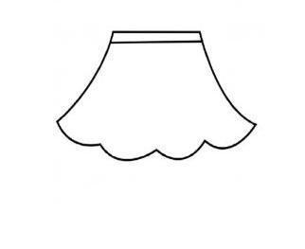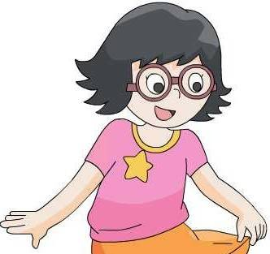 **A: Look at my skirt!**

**Guess Guess!What colour is it now?**

**B: Blue/..?**

**A: Yes,it is./No,it isn’t.**